Friday 1st October 2021

**LORIC CHAMPIONS**

This week’s champions are:

Ezme from Turner Class

Isabel C from Mason Class

Lamari from Millward Class

Chloe from Brunel Class

Freya from Dickens Class

Billy from Fox Class

**CONGRATULATIONS TO YOU ALL!**

This week we say a sad Goodbye to Mrs Halfpenny who starts her retirement. She has worked at Regis for many years and will be greatly missed by the staff, parents and all the children. We wish her every happiness for the future and she promises to return to visit us in the not too distant future.

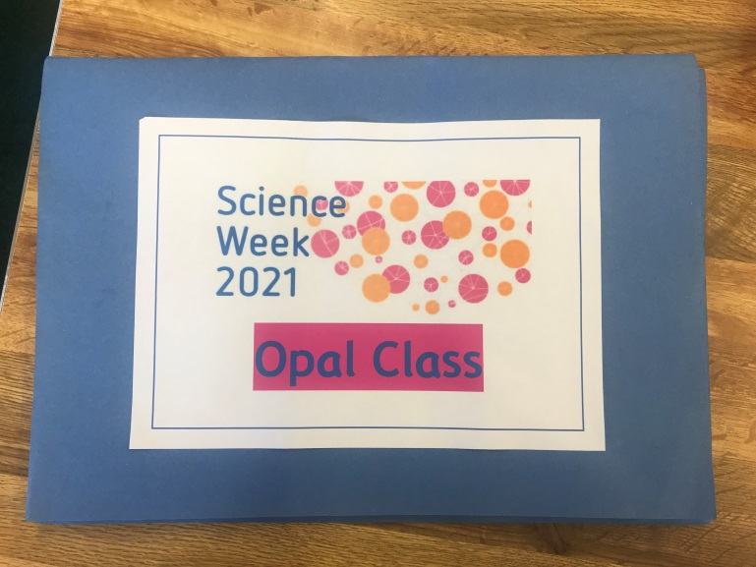



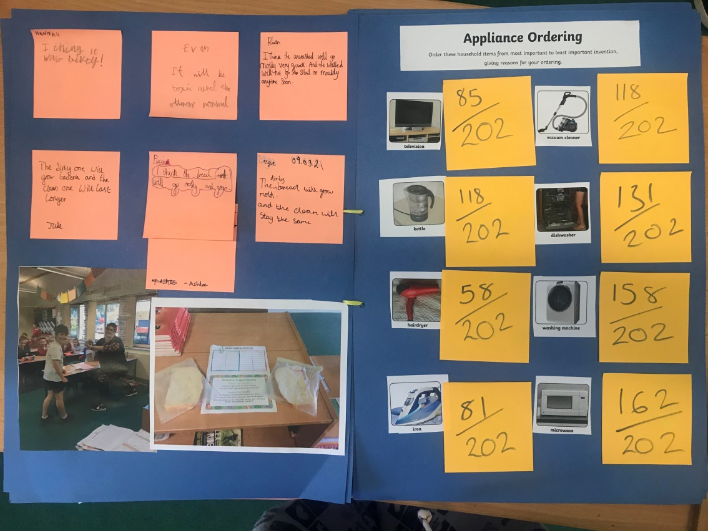

 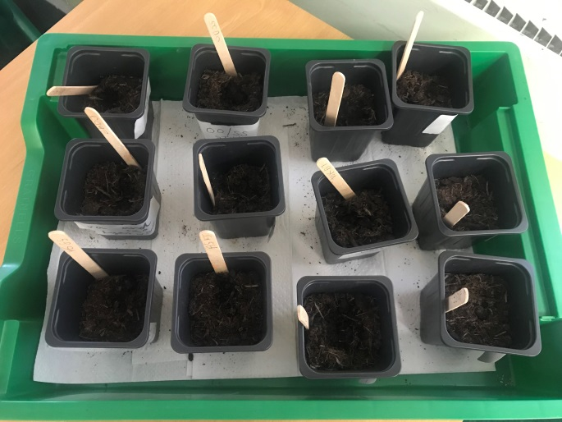

I had the great pleasure of taking 10 children to the **Corsham** **cluster football tournament** yesterday at the Corsham School. We got very wet indeed but the children played brilliantly, showed great determination and sportsmanship.

Very proud of you all: James, Jacob R, Jude, Sophia, Kyra, Pixie, Victor, Ethan, Ashlee and Owen.

Thank you also to the parents who braved the appalling weather to support the team- your encouragement was much appreciated.

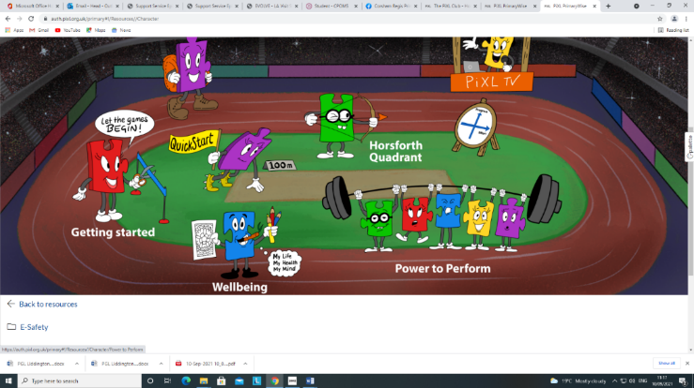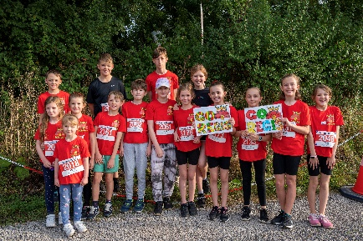

**Reminders:**

Please sign up for your child’s school lunches

Return photo consent forms and sign up to Seesaw

**Whole school attendance**:

Fox: 87% Dickens: 90% Brunel: 86% Millward: 98% Mason: 97% Turner: 90%

There has been a large number of children off school suffering with colds, sickness etc. It is that time of year! Please be reassured that we continue to wash hands and sanitise regularly throughout the school day to try and stop the spread of germs.

**Dates for your diary…**

Monday 4th October- 9.15-12pm Open morning for prospective parents.

Tuesday 5th October: Dickens Class trip around Corsham (re- arranged)

Mr Fletcher from The Corsham School’s IT department is teaching data handling to Year 6 this term!

**Well done and thank you to all the children and adults who volunteered and ran in the 2 and 10k last Sunday and raised funds for our school.**