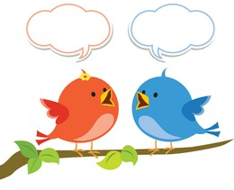
Mason Class Chatter topics

- Can all materials be classified?
- Which materials could I use to make a shelter?
- Are all materials stretchy?
- Can we live without plastic?
- Can we ban paper in school?
- Do all materials change their shape?
- How do scientists develop new materials?
- Are new materials being invented today?
- If I put a coat on a snowman, would he melt?
10.Do all teapots keep tea at the same temperature?

