Autumn 2
Chatter Topics for
Turner Class

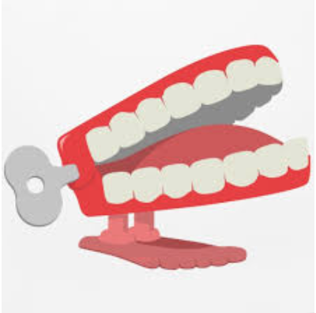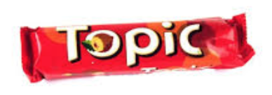

Chatter topic 1:

WHY DO BAKING SODA AND VINEGAR FIZZ?
Chatter topic 2:

WHY DOES SALT MELT SNOW?

