Friday 23rd September 2021

The changing colours of our sensory water bowl…

THRIVE matters at Corsham Regis! Look at the new additions to our Thrive room…a fantastic bubble tube and sensory water bowl. The children’s reactions have been priceless. A calm and inspiration space has been provided for the children to relax, recover and recharge ready to fully embrace their next learning challenges.

**Profound learning:** This week children in Years 4 and 5 were visited by Marnie from Story town Corsham to begin their exciting writing journey. She read them 2 stories: Shadow by Lucy Christopher and The Wilderness War by Julia Green. It was to spark their ideas for writing which will form part of an exhibition later in the term.

**VERY EXCITING NEWS!!** Today I received a call from Nick Mason, the drummer from Pink Floyd! The children in Mason class wrote letters to him and although he is busy rehearsing in London at the moment, it looks as though he is willing to come and pay the children a visit in school. It’s all going on here at Regis! Watch this space!

Have a lovely weekend everyone. Abby Symons Headteacher

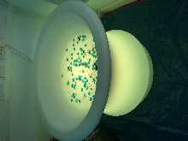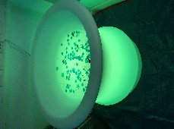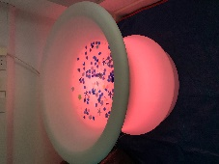

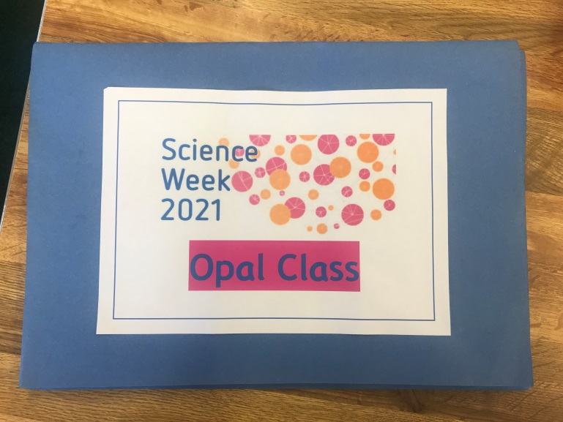

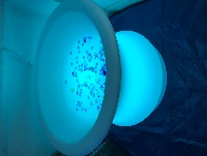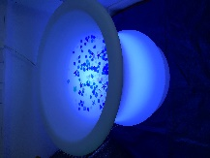

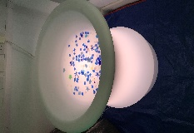 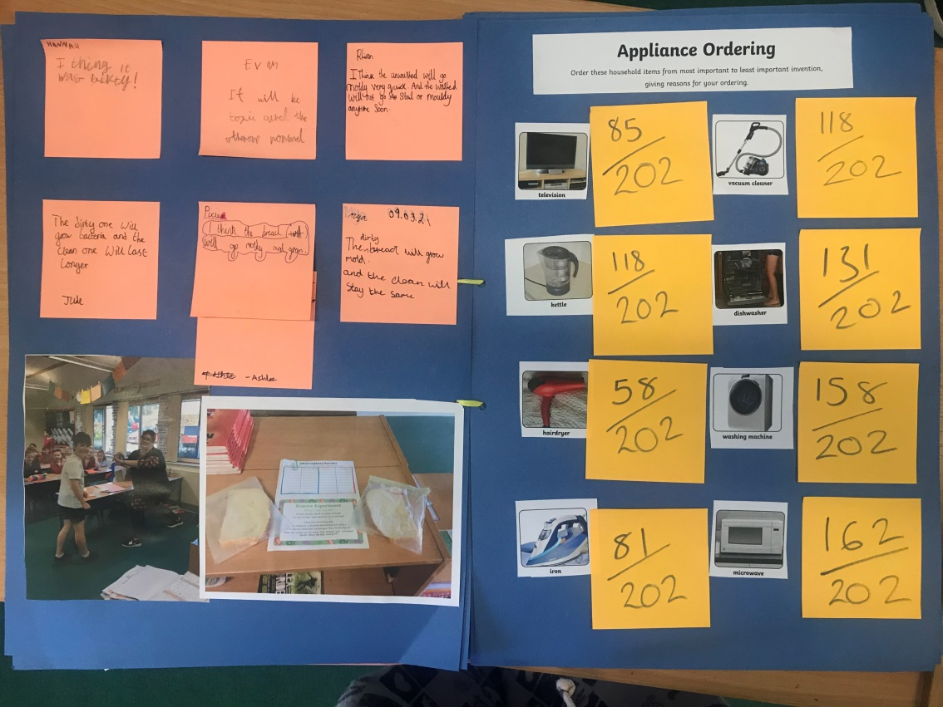

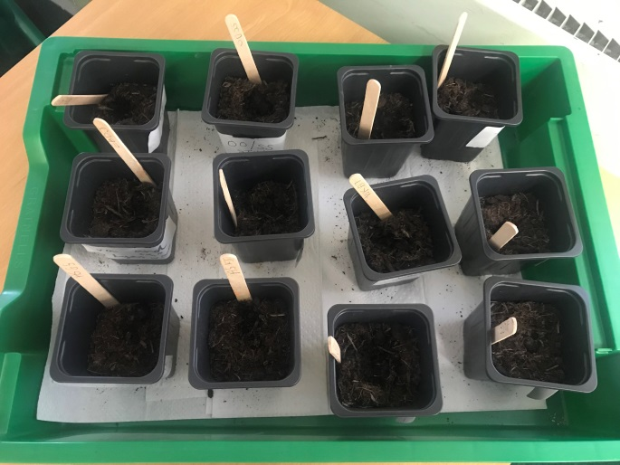

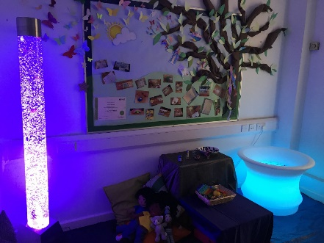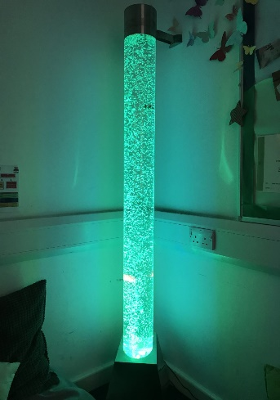

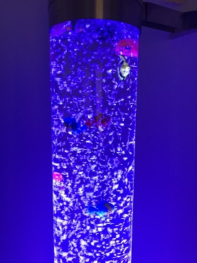

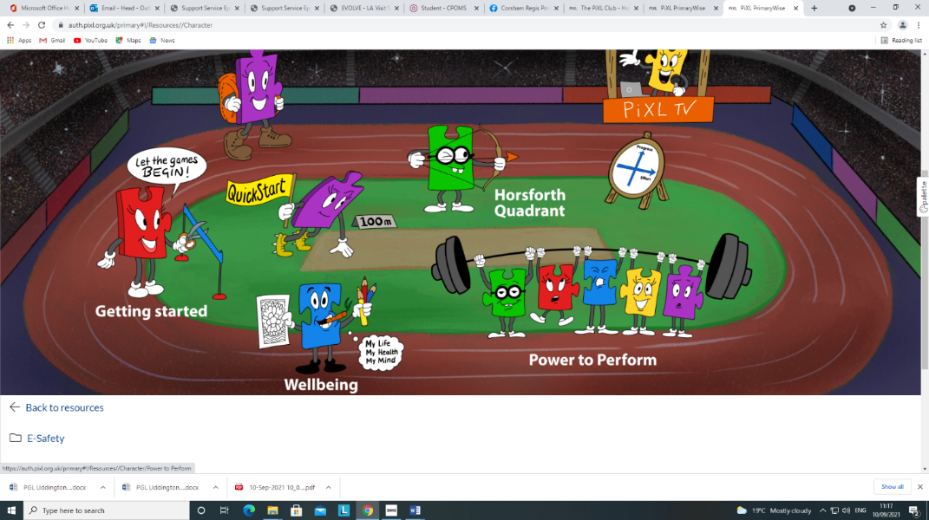

**NEW SENSORY THRIVE ROOM!**

Please look out for **DATA COLLECTION SHEETS** coming home today with your child, check them carefully and return to school ASAP- thank you.

SUPER 6’s

Ethan, Ashlee, Owen, Jude

**Whole school attendance** from 13/9/21 to 17/9/21 is **96%**

**Dates for your diary…**

Tue 28th: Dickens Class trip around Corsham

Fox Class Town and country wow day!

**Mr Fletcher from The Corsham School’s IT department is teaching data handing to Year 6 this term!**

**LORIC CHAMPIONS**

This week’s champions are:

Ethan from Turner Class

Phoebe from Mason Class

Ruby from Millward Class

Harley from Brunel Class

Toby from Dickens Class

Stanley from Fox Class

**CONGRATULATIONS TO YOU ALL!**

**Good luck to all the children and adults running in the Corsham 2k and 10k this Sunday! GO GO TEAM REGIS!**