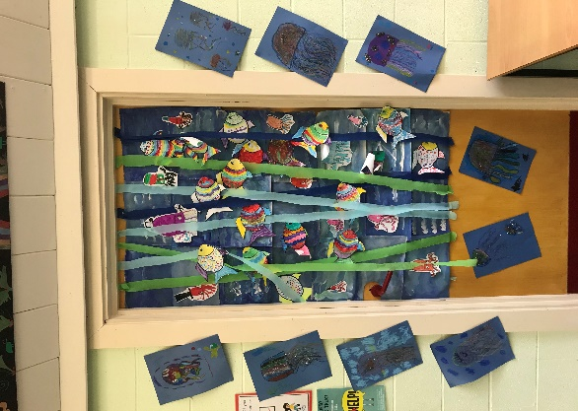Friday 17th September 2021

Brunel class have been crowed the winner of the **Under the Sea** door competition…I am sure you’ll agree that their door looks fantastic.

Special guest Mr Denton (our chair of governors) came to judge the doors and presented their prize at our Friday celebration assembly.

Thank you Mr Denton

**CLUBS:**

**Multisports KS1**

**Cricket Years 4-6**

**Multispoprts KS2**

**STEM Club Yr 5&6**

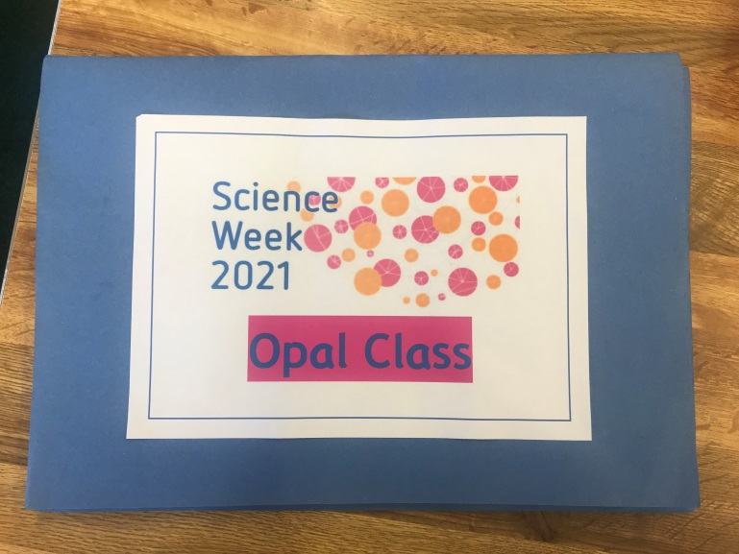

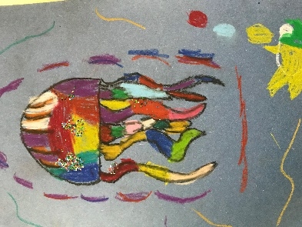 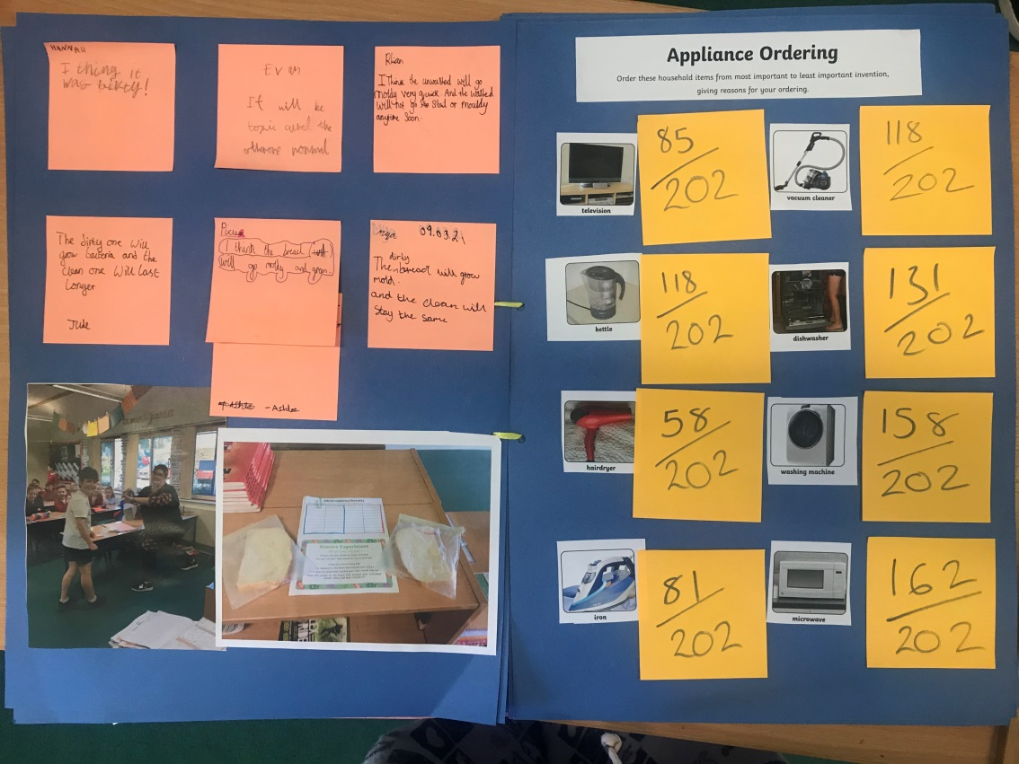

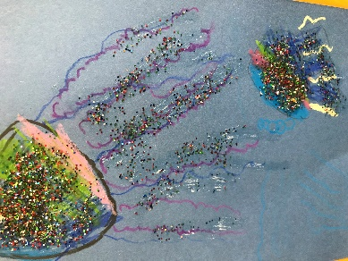 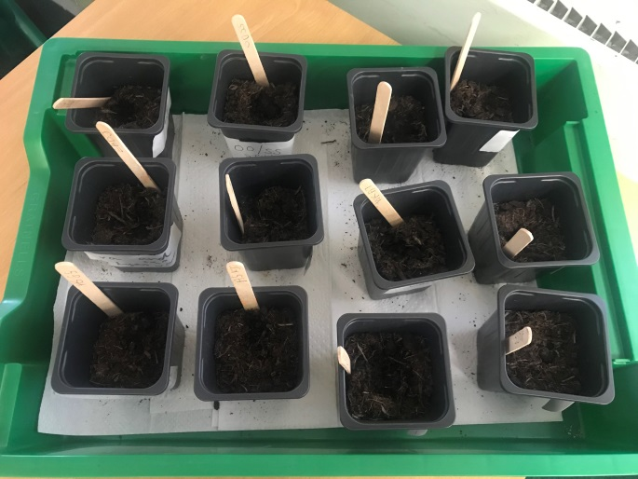

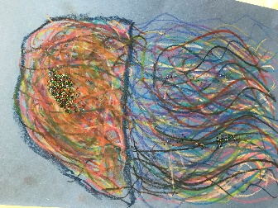

**GOLF Cluster Event**

Yesterday I had the great pleasure of taking 8 children from Years 4 and 6 to The Corsham School to receive some golf coaching from a pro golfer from Chippenham golf club. As always Regis were brilliantly behaved and demonstrated our LORIC skills in abundance: resilience, leadership, communication, organisation and initiative! **Sophia** in Turner class got the only hole in one of the day! Congratulations to her and all involved!

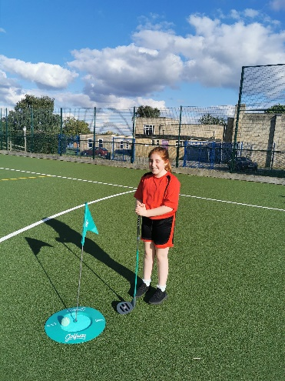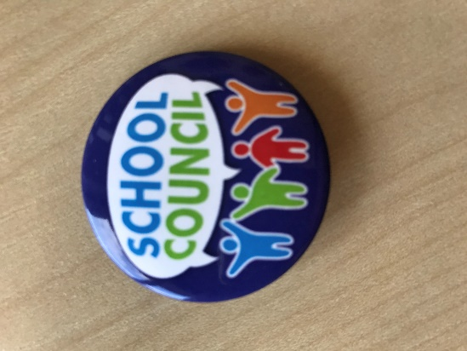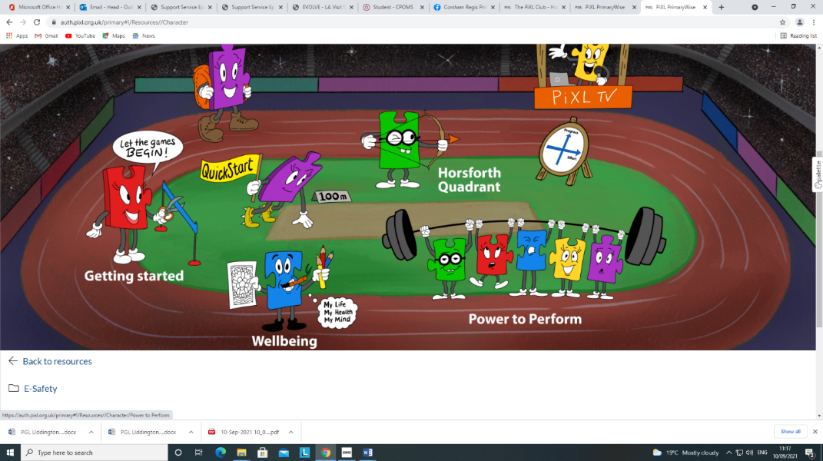

**NEWS FLASH!**

**REGIS ACADEMY COUNCIL IS BACK!**

**Academy Councillors 2021**

Hollie and Huxley

Freya and Jaxon

Kacie and Albie

Tabitha and Kiruthik

Rhea and Nelson

Esme and Jude

**SUPER 6’s**

**Vicky and Lilly**

**LORIC CHAMPIONS**

This week’s champions are:

Ashlee from Turner Class

Andrew from Mason Class

Sophie from Millward Class

Lexi- Mae from Brunel Class

Arlo from Dickens Class

Daisy from Fox Class

**CONGRATULATIONS TO YOU ALL!**