Friday 10th September 2021

**School lunches…**

**Please remember to select your child’s choices through the Chartwells website.**

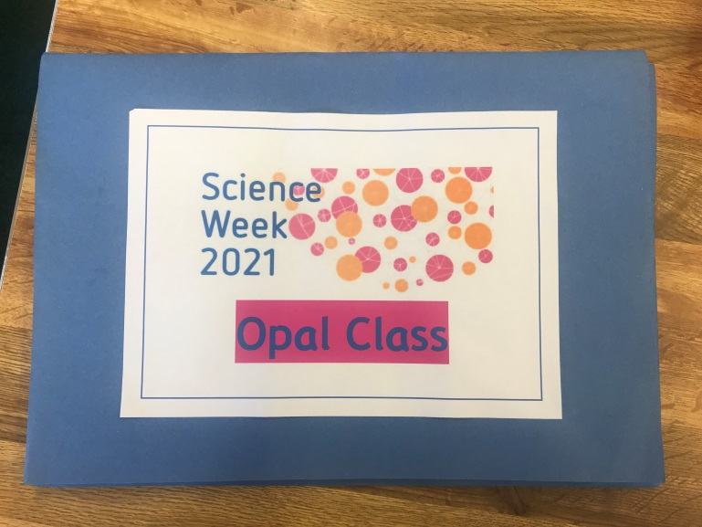

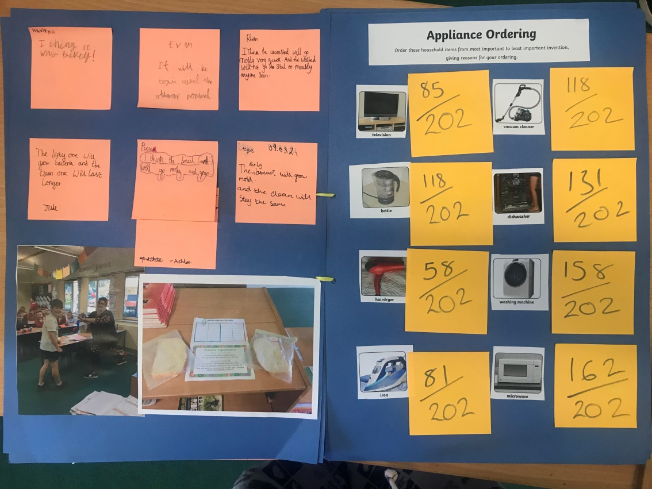

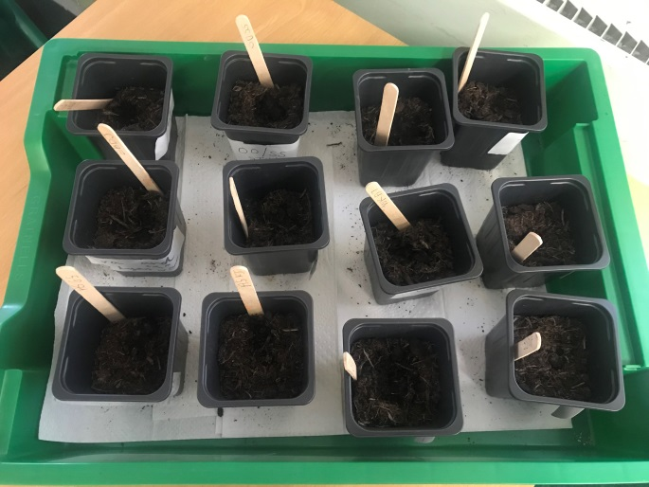

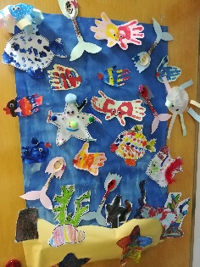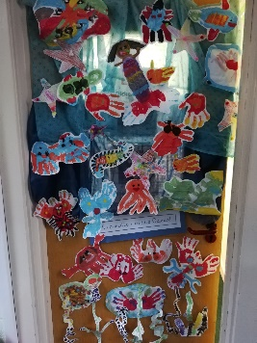

**Saturday 11th September**

**12pm – 4pm**

**Come by our stall (near Oxfam) and support Friends of Regis. If you can spare an hour to help run our stall, please get in touch**

**friendsofregis@gmail.com**

**Please remember to sign up to Seesaw using your personal QR code.**

Marshalls needed

Corsham Running Club have asked for 12 volunteers from Corsham Regis to help on the morning of **Sunday 26th September** for the Corsham 10K. There’s time to watch the children in the 2K first.

Our school receives a donation in return for the marshalling and you'll be able to cheer on our runners!

It's a fun community event so if you can help, please get in touch.

friendsofregis@gmail.com

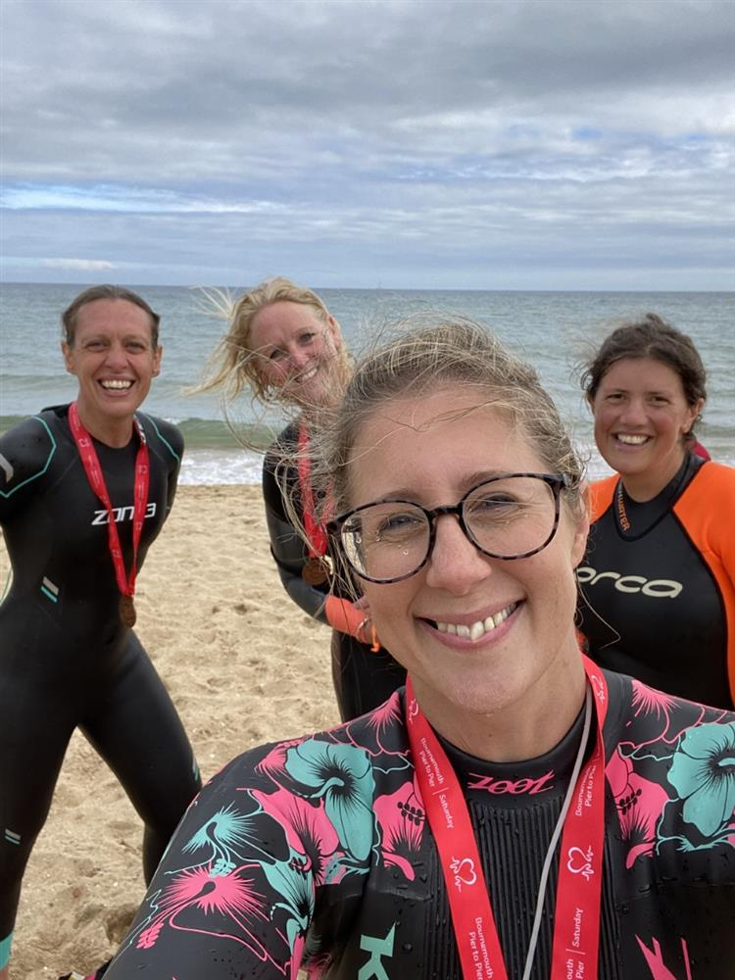

This Saturday and Sunday I will be completing (hopefully) a crazy 24 hour relay swimming challenge to raise money for Level Water a charity that pays for children with disabilities to learn to swim.

I believe that everyone should have the opportunity to learn to swim and fall in love with the water.

If you would like to find out more or to sponsor me and my team search ‘Just giving Fantastic4’ or follow the link on the schools Facebook page.

Thank you