Friday 10th September 2021

Welcome back everyone to the new school year. It has been a very exciting start to the term with all classes settling in well. The children have been learning all about their new class names and our new starters have been brilliant, already showing the LORIC skills of resilience, communication and organisations- we are very proud of your all.

The adults are also delighted to be back to inspire the curious minds of our young learners and what a start we have made! We have dived straight in to a whole school wellbeing art week titled ‘Under the Sea’. The classes have been very busy creating their own drama and dances, learning sea shanties and songs and even creating their own sea creature masterpieces.

But things are heating up under the sea, as classes go head to head in an underwater classroom door decorating competition. With teachers and children working together on their creations to see who will be crowned the king of the sea!

Have a happy and enjoyable weekend Mrs Abby Symons

**CLUBS:**

**Multisports KS1**

**Cricket Years 4-6**

**Multispoprts KS2**

If you have not managed to secure a place in these clubs do look out for future clubs and events.

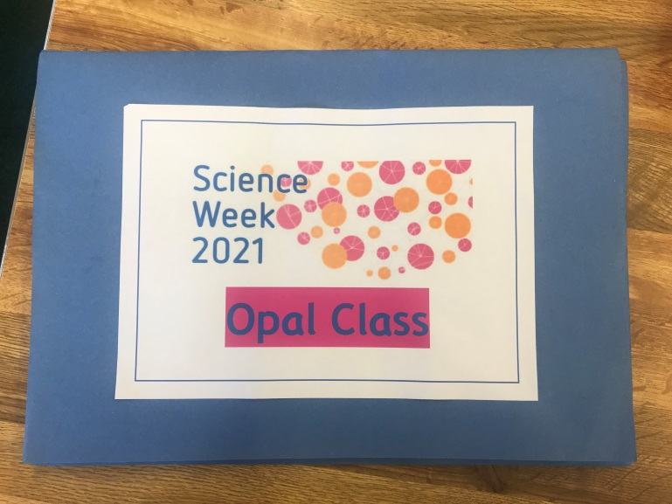

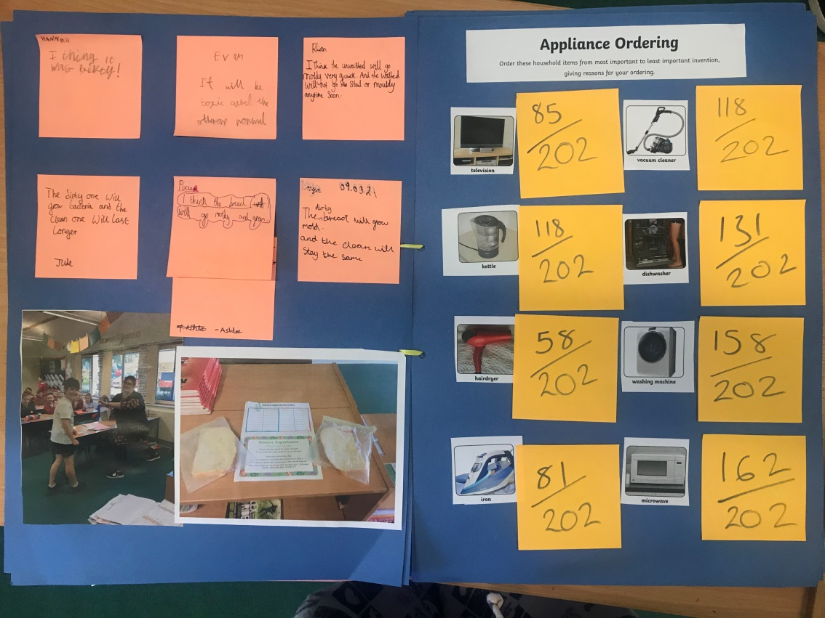

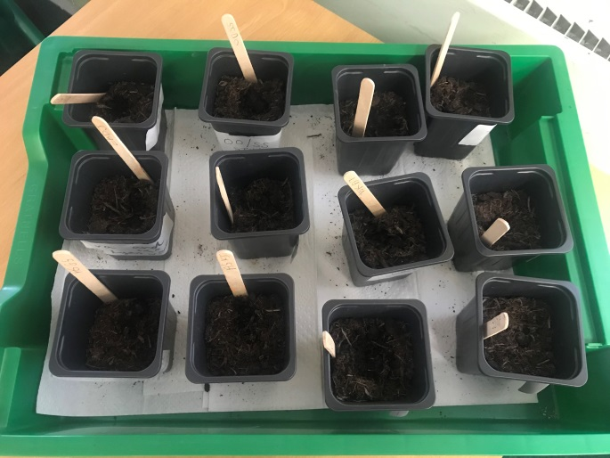

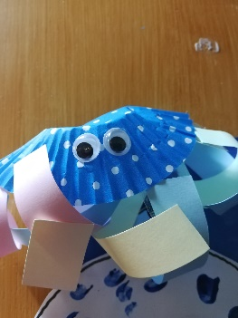

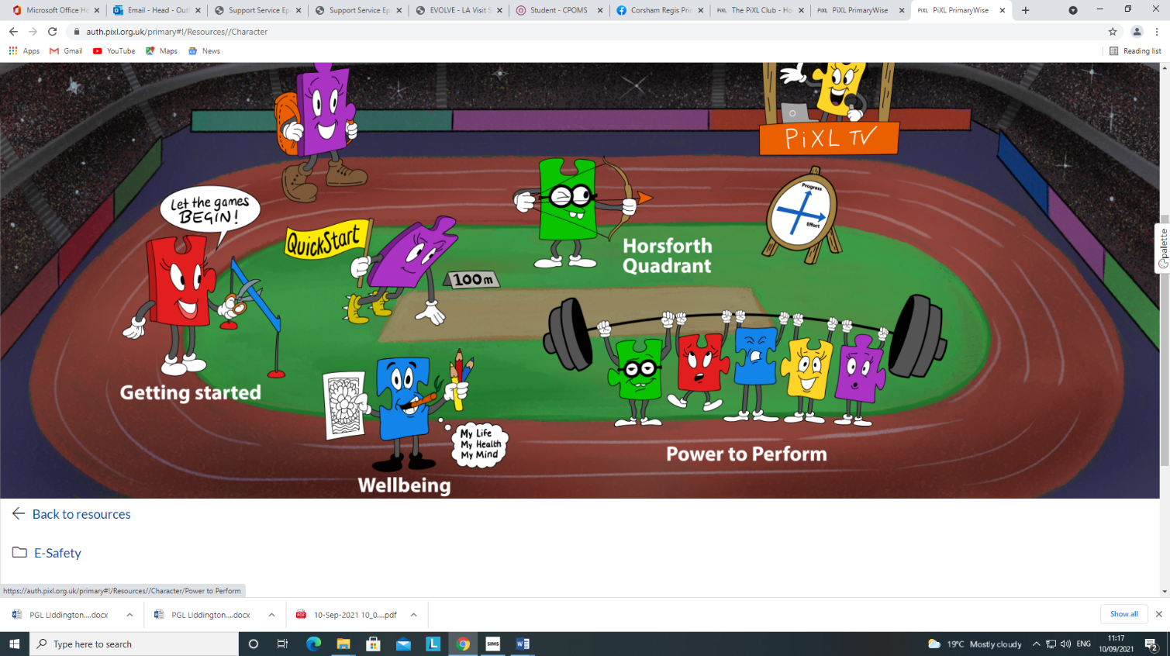

**LORIC CHAMPIONS**

EXCITING NEWS…We have changed our reward system in school to link with our curriculum intent: LORIC stickers are awarded for each of the different skills: leadership, organisation, resilience, initiative and communication and stickers placed on class charts. When children receive 10 stickers for one of the skills they are awarded with a button badge of that colour to wear. Each class teacher selects a child to be a LORIC champion each week, they are awarded with a lanyard to wear the following week and given a certificate to take home. The awards are presented in a whole school assembly every Friday.

This week’s champions are:

Eva Booth from Turner Class

Rea from Mason Class

Gracie-Mae from Millward Class

Logan from Brunel Class

Kuridhaya from Dickens Class

Enzo from Fox Class

**CONGRATULATIONS TO YOU ALL!**