Local Area –  Skills and Fieldwork | Who am I and where am I?
- What is a human feature?
- What is a physical feature?
- Where is the school and what is it like around the school?
- How could you use the words soil, vegetation and weather to describe the school and where it is?
- What are some key places and features you know in Corsham?
- Where are the key places and features of Corsham on an ariel image or map?
- What geographical questions could you ask about where you live?
- How do you know if a place is a city, town, village, coastal or rural area?
- How could you use the words town, factory, farm, house, office and shop to describe Corsham?
- What are the world’s continents and oceans called and where are they on a map?
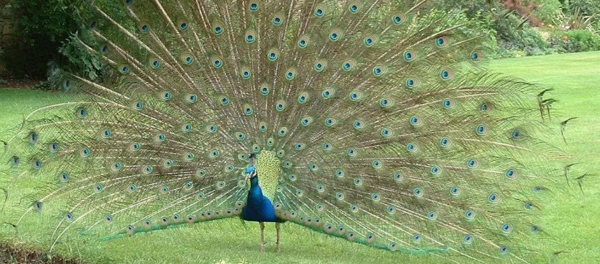

Related Milestones:
Geog M1:
• Use simple fieldwork and observational skills to study the geography of the school and the key human and physical features of its surrounding environment. Vocabulary to refer to: key physical features, including: beach, coast, forest, hill, mountain, ocean, river, soil, valley, vegetation and weather. • Use aerial images and plan perspectives to recognise landmarks and basic physical features. • Identify land use around the school. • Name and locate the world’s continents and oceans. • Ask and answer geographical questions (such as: What is this place like? What or who will I see in this place? What do people do in this place?). • Identify the key features of a location in order to say whether it is a city, town, village, coastal or rural area. Vocabulary: • key human features, including: city, town, village, factory, farm, house, office and shop.

