Autumn 1
Where am I?
Chatter Topics for
Brunel Class

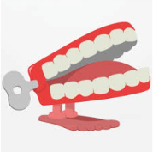
Chatter topic 1: Where would you choose to live – by a beach or in a snowy mountainside? Why?
Chatter topic 2: Imagine you are a guide and talk about what it is like to live in Corsham?
Chatter topic 3: What country would you like to live in and why?

Chatter topic 4: Look at this picture of Corsham Court. Make up a story about someone who could have lived there.

