Autumn 1
Chatter Topics for
Turner Class

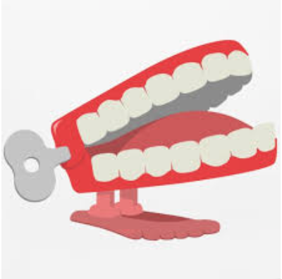
Chatter topic 1:
Why are maps so important?
Chatter topic 2:
How has navigation changed over time?

