Autumn 1 Chatter Topics for
Fox Class

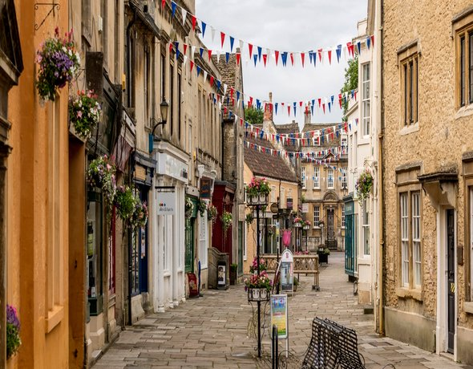

- Where do you live?
- What is your address?
- How can you describe Corsham using the words house, town and shops?
- What is the difference between Corsham and Biddestone?
- What sort of places might you find on your way down to town?
- What is your favourite shop in Corsham and why?

