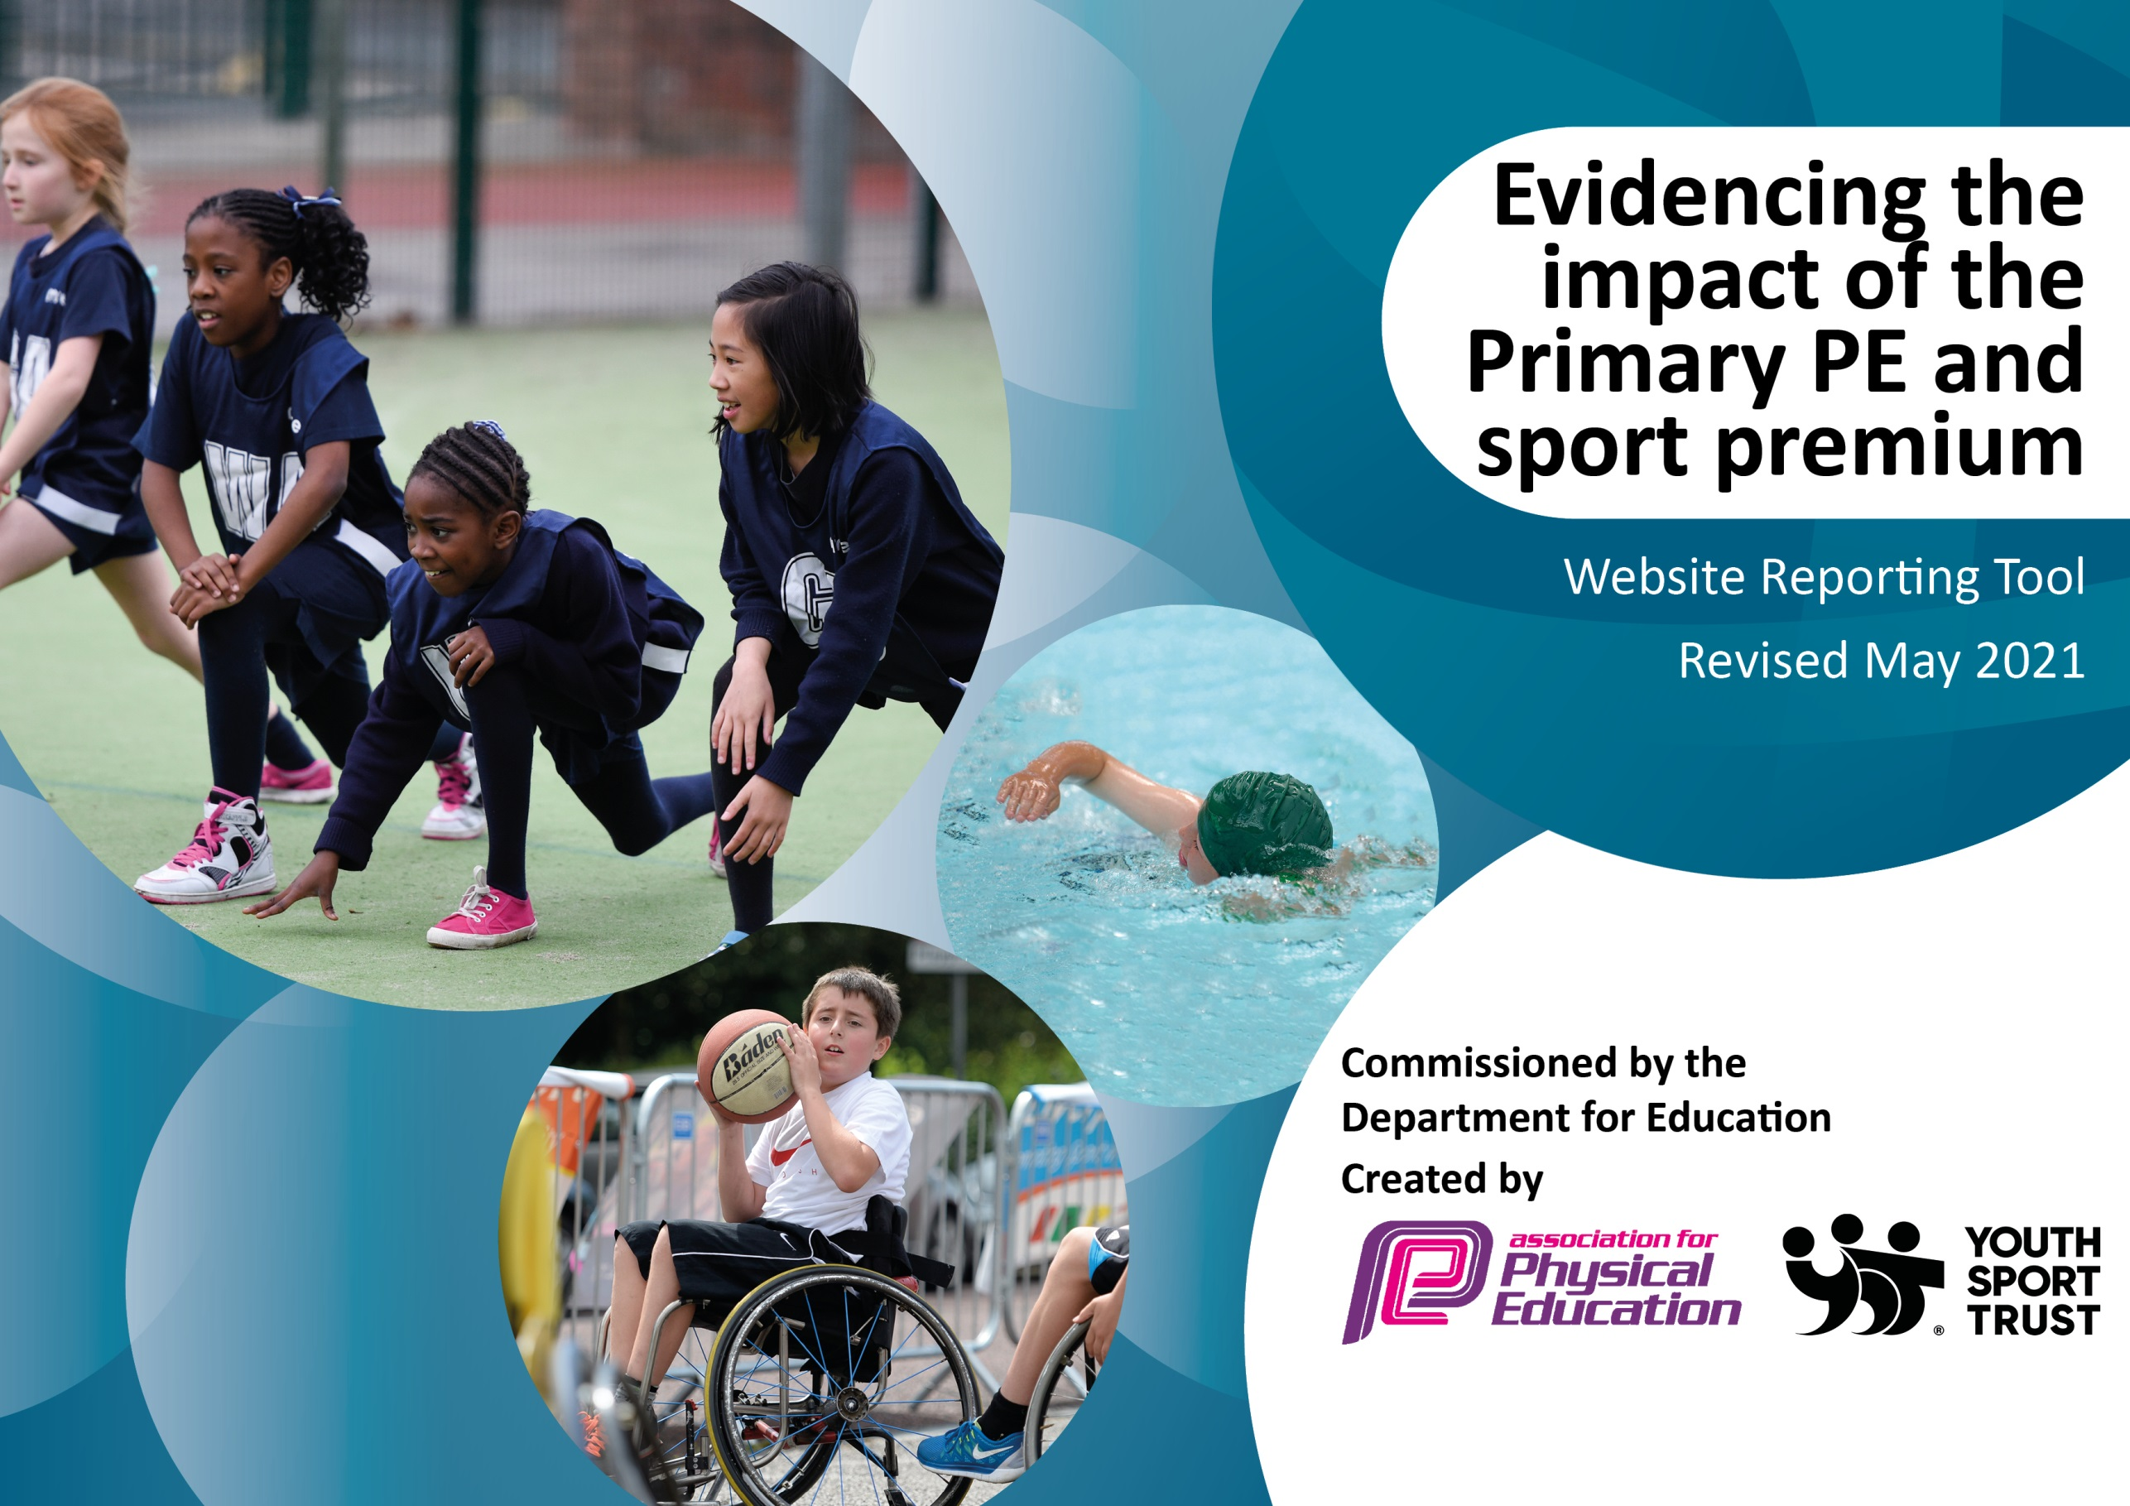

It is important that your grant is used effectively and based on school need. The Education Inspection Framework (Ofsted 2019 p64) makes clear there will be a focus on ‘whether leaders and those responsible for governors all understand their respective roles and perform these in a way that enhances the effectiveness of the school’.

Under the Quality of Education criteria (p41) inspectors consider the extent to which schools can articulate their curriculum (INTENT), construct their curriculum (IMPLEMENTATION) and demonstrate the outcomes which result (IMPACT).

To assist schools with common transferable language this template has been developed to utilise the same three headings which should make your plans easily transferable between working documents.

Schools must use the funding to make additional and sustainable improvements to the quality of Physical Education, School Sport and Physical Activity (PESSPA) they offer. This means that you should use the Primary PE and sport premium to:

- Develop or add to the PESSPA activities that your school already offer
- Build capacity and capability within the school to ensure that improvements made now will benefit pupils joining the school in future years
- The Primary PE and sport premium should not be used to fund capital spend projects; the school’s budget should fund these.
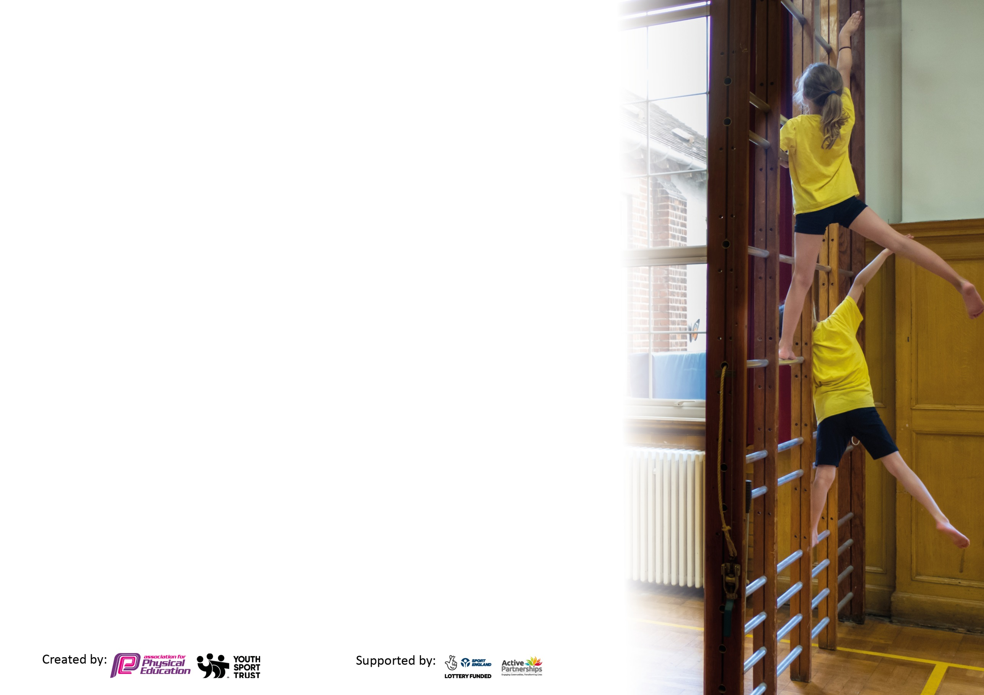
Please visit gov.uk for the revised DfE guidance including the 5 key indicators across which schools should demonstrate an improvement. This document will help you to review your provision and to report your spend. DfE encourages schools to use this template as an effective way of meeting the reporting requirements of the Primary PE and sport premium.

We recommend you start by reflecting on the impact of current provision and reviewing the previous spend.

Schools are required to publish details of how they spend this funding, including any under-spend from 2019/2020, as well as on the impact it has on pupils’ PE and sport participation and attainment by the end of the summer term or by 31st July 2021 at the latest.

We recommend regularly updating the table and publishing it on your website throughout the year. This evidences your ongoing self-evaluation of how you are using the funding to secure maximum, sustainable impact. Final copy must be posted on your website by the end of the academic year and no later than the 31st July 2021. To see an example of how to complete the table please click HERE.

Please note: Although there has been considerable disruption in 2020 it is important that you publish details on your website of how you spend the funding - this is a legal requirement.
Support for review and reflection - considering the 5 key indicators from DfE, what development needs are a priority for your setting and your pupils now and why? Use the space below to reflect on previous spend and key achievements and areas for development.

N.B. In this section you should refer to any adjustments you might have made due to Covid-19 and how these will influence further improvement.
Key achievements to date until July 2021: | Areas for further improvement and baseline evidence of need:
Registers of participation show that there were approximately 65 uptake of clubs in 2020/21 this was due to not mixing bubbles and clubs only being available for certain year groups which limited the numbers  Continued competitive sport with primaries in the cluster in the summer term.  Staff have been supported by Up and Under coaches throughout the academic year.  Our school website and newsletters feature match reports and competition results and children’s sporting achievement outside of school are celebrated.  Chance to Shine Cricket taught all year groups cricket sessions and this continued virtually during the January 2021 lockdown period. Key Stage Two children also took part in challenge days in the Summer term. | To raise confidence in the use of Real PE resources  To reinstate sports leaders within Years 5 & 6.  Intent and Implementation documents to be completed and adapted throughout the year  To broaden the experiences for the children at Corsham Regis through building links with Bath Rugby club  For a greater number of children to be able to swim 25 metres unaided  For Year 6 pupils to go on a residential trip to experience broader outdoor and adventurous activities

Did you carry forward an underspend from 2019-20 academic year into the current academic year? YES
Total amount carried forward from 2019/2020 £4726
+ Total amount for this academic year 2020/2021 £17,740
= Total spent by 31st July 2021 £8389
Total to carry forward from 2020/2021 due to Coronavirus £9351

Meeting national curriculum requirements for swimming and water safety.

N.B Complete this section to your best ability. For example, you might have practised safe self-rescue techniques on dry land which you can transfer to the pool when school swimming restarts.
Due to exceptional circumstances priority should be given to ensuring that pupils can perform safe self-rescue even
if they do not fully meet the first two requirements of the NC programme of study.
What percentage of your current Year 6 cohort swim competently, confidently and proficiently over a distance of at least 25 metres?  N.B. Even though your pupils may swim in another year please report on their attainment on leaving primary school at the end of the summer term 2021.  Please see note above. | 58%  15/26
What percentage of your current Year 6 cohort use a range of strokes effectively [for example, front crawl, backstroke and breaststroke]?  Please see note above. | 46%  12/16
What percentage of your current Year 6 cohort perform safe self-rescue in different water-based situations? | N/A (not covered in sessions)
Schools can choose to use the Primary PE and sport premium to provide additional provision for swimming but this must be for activity over and above the national curriculum requirements. Have you used it in this way? | No

Action Plan and Budget Tracking
Capture your intended annual spend against the 5 key indicators. Clarify the success criteria and evidence of impact that you intend to measure to evaluate for pupils today and for the future.

Academic Year: 2020-21 | Total fund allocated: £17,740 | Date Updated: July 2021
Key indicator 1: The engagement of all pupils in regular physical activity – Chief Medical Officers guidelines recommend that primary school pupils undertake at least 30 minutes of physical activity a day in school |  |  |  | Percentage of total allocation:
 |  |  |  | 10%
Intent | Implementation |  | Impact
Your school focus should be clear what you want the pupils to know and be able to do and about  what they need to learn and to  consolidate through practice: | Make sure your actions to achieve are linked to your intentions: | Funding allocated: | Evidence of impact: what do pupils now know and what can they now do? What has changed?: | Sustainability and suggested next steps:
Ensure pupils are active in PE lessons and discuss how exercise makes them feel.  Provide opportunities for pupils to raise their heart rate that are accessible to all  Ensure that teaching and learning is sufficiently differentiated to challenge all groups of learners Silver School Games Mark accreditation  For participation in sport to be promoted through fund raising events | Monitor, evaluate and review teachers’ teaching, planning and assessment termly, and provide feedback.  Submit application and prepare evidence for external moderation in May 2021 Promote and finance extracurricular clubs / lunchtime Huff and Puff  Children In Need Fundraising Pudsey Boot camp event held for all pupils to engage in 40 minutes of additional exercise  Virtual online running event- Lands end to John O Groats  Outdoor discos in bubble groups | £2150  (SSCo payment is stated below in Key Indicator 5)  £30 for certificates of participation | PE lesson observations show pupils to be engaged and active and able to talk about how exercise makes them feel  PE SL file PE Display board.  Application delayed due to Covid-19 restrictions  Children got to experience outdoor exercises ‘Bootcamp’ style to broaden their understanding of exercises that they can do to keep fit. All children from FS2 –Yr6 participated.  Enjoyment and team spirit of participating in a group event was reported by participants  High participation numbers and children reported great enjoyment of dancing outside. | Strive for Silver Games Mark accreditation  Continue to use Up and Under Ltd for mentoring, coaching and extra-curricular club provision  Continue to use sport to fundraise for charities and the school itself.
Key indicator 2: The profile of PESSPA being raised across the school as a tool for whole school improvement |  |  |  | Percentage of total allocation:
 |  |  |  | 23%
Intent | Implementation |  | Impact
Your school focus should be clear what you want the pupils to know and be able to do and about  what they need to learn and to  consolidate through practice: | Make sure your actions to achieve are linked to your intentions: | Funding allocated: | Evidence of impact: what do pupils now know and what can they now do? What has changed?: | Sustainability and suggested next steps:
Gather pupil feedback about extra-curricular clubs and competitions, and celebrate pupils’ achievement.  Providing opportunities for pupils to become more active in lessons and therefore more engaged academically to improve outcomes | Sports mentoring for pupils vulnerable to underachievement / Change for life approach Update PE display board with records of achievement and participation Sportsperson of the Year award for Year 6 – Hynes Cup Year 6 | £5000 to Up and Under Sports  £50 Trophy | Registers from clubs attended indicate that 65 children across the school participated in sporting clubs.  Pupil achievements celebrated through assemblies, the school newsletter and social media. | Upon developing and reinstating a Sports Crew (21/22) take them to PE Conference as part of their development  Continue to use Up and Under Ltd for mentoring, coaching and extra-curricular club provision  Set up Sports Crew Leaders in KS2 playground at lunchtimes.

Key indicator 3: Increased confidence, knowledge and skills of all staff in teaching PE and sport |  |  |  | Percentage of total allocation:
 |  |  |  | 32%
Intent | Implementation |  | Impact
Your school focus should be clear | Make sure your actions to | Funding | Evidence of impact: what do | Sustainability and suggested
what you want the pupils to know | achieve are linked to your | allocated: | pupils now know and what | next steps:
and be able to do and about | intentions: |  | can they now do? What has
what they need to learn and to |  |  | changed?:
consolidate through practice:
Up and Under Sports mentoring of staff. Assess pupils’ progress in Physical Literacy | Create a timetable of planned mentoring support over the academic year from Up and Under Coaches for teaching staff using a model of 2 x observations, 2 x joint teaching and 2 x teacher teaching with interjections from Up and Under Staff Teaching staff to teach REAL PE weekly and evaluate pupil attainment. New teachers to teach REAL PE alongside Up and Under Sports coaches | £7000 to Up and Under Sports | Teachers confidence in coaching sport has increased through quality and targeted tutoring. All children have taken part in two hours of high quality PE  PE lesson observations and evidence trails | Continue to use Up and Under Ltd for mentoring, coaching and extra-curricular club provision
Key indicator 4: Broader experience of a range of sports and activities offered to all pupils |  |  |  | Percentage of total allocation:
 |  |  |  | 30%
Intent | Implementation |  | Impact
Your school focus should be clear | Make sure your actions to | Funding | Evidence of impact: what do | Sustainability and suggested
what you want the pupils to know | achieve are linked to your | allocated: | pupils now know and what | next steps:
and be able to do and about | intentions: |  | can they now do? What has
what they need to learn and to |  |  | changed?:
consolidate through practice:
Increase the number of opportunities for pupils to participate in high quality extracurricular PE | Invite representatives from local clubs to promote their sports and club in school assemblies Increase possibilities for SEND pupils to participate in sporting events | £6500 to Up and Under Sports | Club registers (65 children participated in clubs) this was les than in previous years due to restrictions around the mixing of bubbles and lockdown from Jan 2021-March 2021 | Continue to use Up and Under Ltd for mentoring, coaching and extra-curricular club provision  Participate in wider sporting events including West Wilts inclusive events

Key indicator 5: Increased participation in competitive sport |  |  |  | Percentage of total allocation:
 |  |  |  | 5%
Intent | Implementation |  | Impact
Your school focus should be clear | Make sure your actions to | Funding | Evidence of impact: what do | Sustainability and suggested
what you want the pupils to know | achieve are linked to your | allocated: | pupils now know and what | next steps:
and be able to do and about | intentions: |  | can they now do? What has
what they need to learn and to |  |  | changed?:
consolidate through practice:
Attend cluster network meetings (Corsham cluster schools) led by SSCo | Meetings and on-going discussions with other PE leaders from the Corsham cluster to feedback to teachers at Regis.  Participate in Corsham Cluster Sport Fixtures | The Corsham School PE Dept. for SSCo £1000 | PE SL file – minutes (limited meetings due to Covid-19 interruptions)  1x event attended by 10 pupils where we came second out of the schools attending. | Continue to subscribe to SSCo 21/22  Participate in the full timetable of events including those further afield.

Signed off by
Head Teacher: | - Symons
Date: | 12/07/2021
Subject Leader: | - Symons
Date: | 12/07/2021
Governor: | C.Denton
Date: | 20/7/2021

