Summer 6 Homework

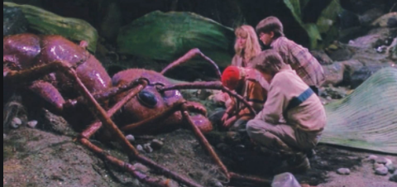
- You have been shrunk to the size of a spider, you are lost in the garden, just like ‘Honey I Shrunk the Kids!’. Write a diary extract about your day as a mini-beast!

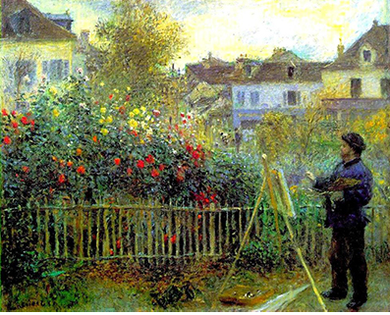
- Choose a sunny dry day to sit outside in your garden/the park/the garden of a friend/family member and do a still life drawing/painting of a flowering plant.

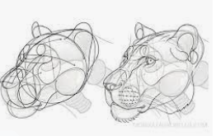
- Create a piece of artwork which is inspired by an animal of your choice.

- Create a plants or animals word search for someone in your family to complete.

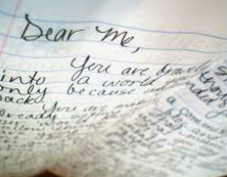
- Write a letter to your future self, tell them all the things you want them to remember about being at Corsham Regis Primary.

