Summer Term 2 Homework

Thinking about plants, living things and habitats

Create a fact file about your favourite living thing.
- Design a poster about your favourite living thing.
- Make a model or sculpture.
- Make an animation of an animal, plant or insect.
- Could you write a story about an animal?
- Design a bug hotel.
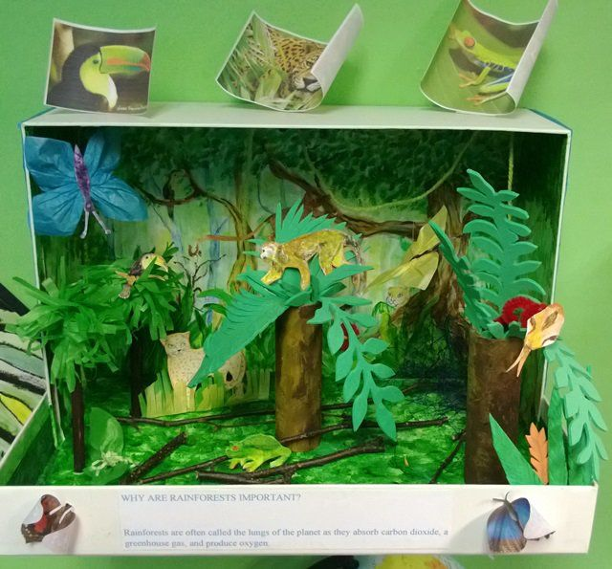
- Make a habitat diorama.

