Summer 6
Chatter Topics for Amethyst Class
Living things, habitats and life-cycles

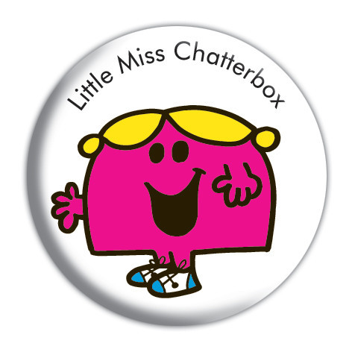Chatter Topics:
- What are your favourite things about being outside in nature? Think about the 5 senses.
- Are there any animals you are afraid of? Why? What is it that bothers you?
- If you could design your own garden what flowering plants would you choose to have?
- If you had to be a mini-beast which one would you be? Why?
- When you think about getting old, what do you think you will remember most about your childhood? Ask the other members of your family.

