Summer 2
Chatter Topics for
Onyx Class

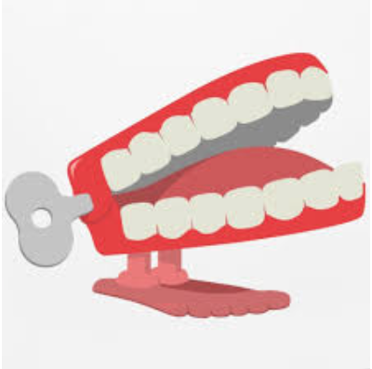
Chatter topic 1: What does a habitat need for the animals that live in it to survive?
Chatter topic 2: Why can’t mammals live in a water habitat?
Chatter topic 3: How could you help the animals that live in habitats around Corsham?
Chatter topic 4: What animals might live in a woodland habitat?

