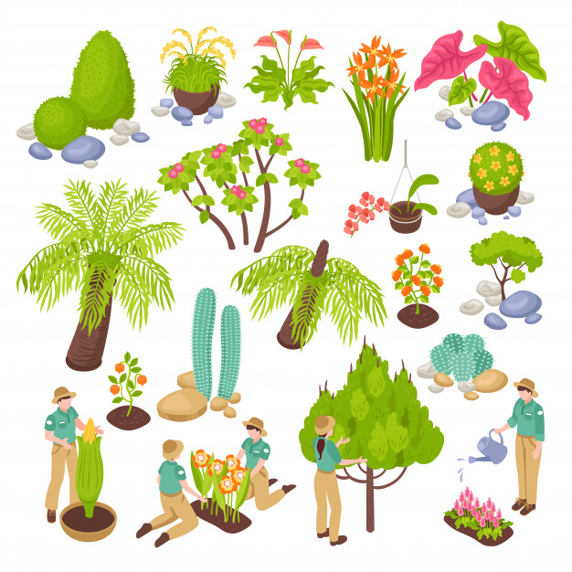
Homework Options
- Design a new species of tree. What is it called? What are its flowers like? What fruit does it grow? How tall is it? What shape are its leaves? How far do its roots reach? Is it deciduous or evergreen?
- What minibeasts can you find in your garden? Make a list of the different ones you find and tally up how many of each there are.
- Make a simple bug hotel. First, research what you could use.
- Write a leaflet to tell visitors to your house about some of the plants in your garden, or in your street. Will you choose trees, wild flowers or garden flowers? Perhaps you will choose all three!
- Draw a diagram of the life cycle of your favourite plant. What will you choose? What labels will you include?

