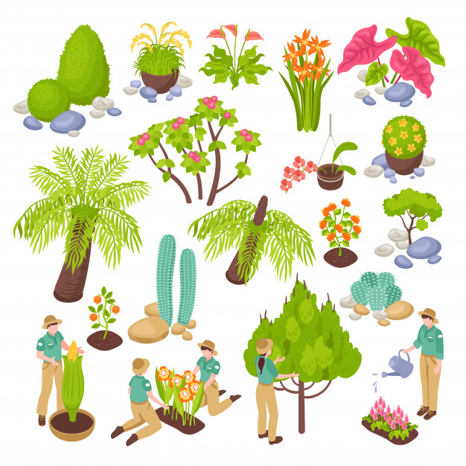
Chatter topics
- Tell a grown up about the differences between living and non-living things.
- Choose two summer flowers that are growing nearby and compare them. Describe what is the same about them and how are they different?
- Which minibeast is your favourite? Why? Where does it live and why does it live here? What is so special about it?
- How many different trees do you pass on your way to school? As you pass each one, describe its leaves to the person you are with.
- Read a story or a poem involving plants or seeds and retell or recite it to an adult. Why did you choose it? What did you enjoy about it most?

