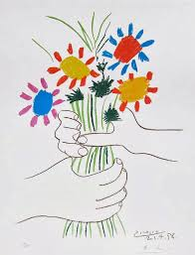
Summer Term 5 Homework

Thinking about Pablo Picasso

- Create a photo collage of them and their work.
- Paint a portrait of them.
- Create a storyboard of a key event in their life
- Do a junk model to represent them or their work
- Write a poem or song about them
- Create a short animation about them

