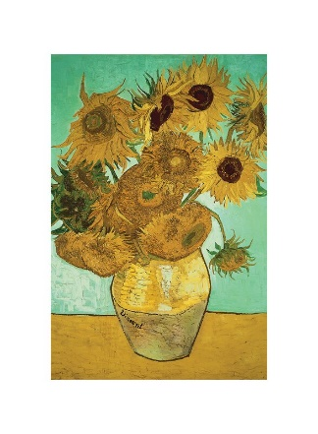
Homework Options
- Paint or draw a self-portrait of your own.
- Research and make a fact file about an artist friend of Van Gogh’s, to share with the class.
- Draw a plan or picture of your own bedroom.
- Pretend you are Van Gogh, and write a letter to your brother, Theo, describing your latest painting. What is it of? Where did you paint it? What colours have you used? Was it difficult to do? Are you pleased with it?
- Make a collage picture of a sunflower.

