Summer 1
Chatter Topics for
Garnet Class

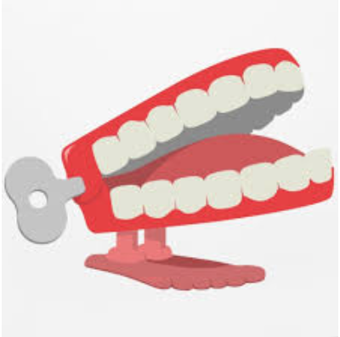
Find a piece of art that you like.
Chatter topic 1: What is going on in this picture? What do you see, and what makes you think that?
Chatter topic 2: What title would you give the art and why?
Chatter topic 3: What do you think is happening in this work?

Chatter topic 4: What do you think the meaning of this work is and how did you come to think this?

