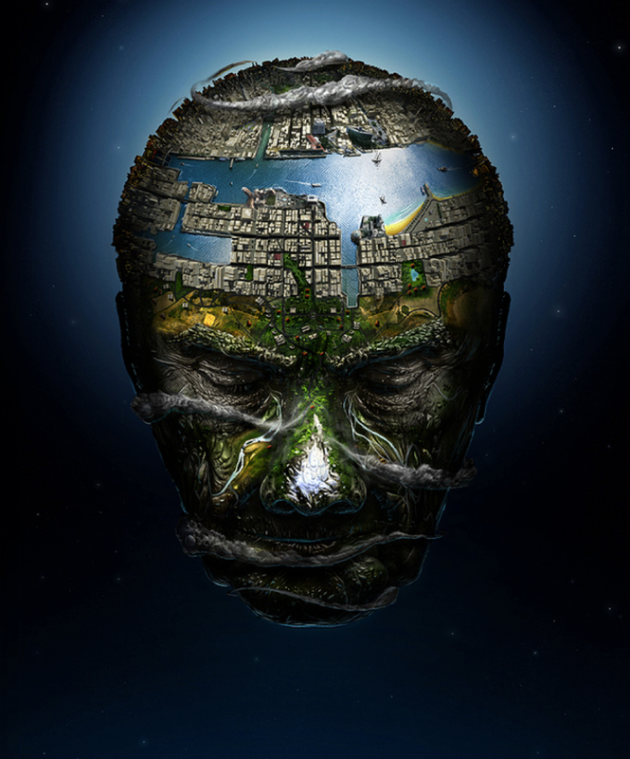

Can you read through the poem below and highlight any similes and metaphors?
Recap:
- A simile is a way of describing something by comparing it to something else using 'like' or 'as',
- Metaphors compare one thing to another but do not contain the words 'as' or 'like'.

He was the World.
His nose was like an enormous, ice-tipped mountain.
His forehead was a mighty river flowing across his brow.
His eyes were like deep canyons; colossal gouges chiselled from his rocky face.
His tears were waterfalls cascading down his grassy cheeks.
He was the World.

Can you continue the poem? Can you think of some of your own similes and metaphors to use?
Can you think of other features on a face to write about? Which features could you include?
Can you think of any geographical physical features we have been exploring? Which ones could you use?
Key vocabulary:
Forest  Weather –snow, hail, rainbows, clouds, sun  Coast  Hills  Cliffs  Valley  Beach  Stream  Sea  Ocean  Volcano  Tsunami  Wave | 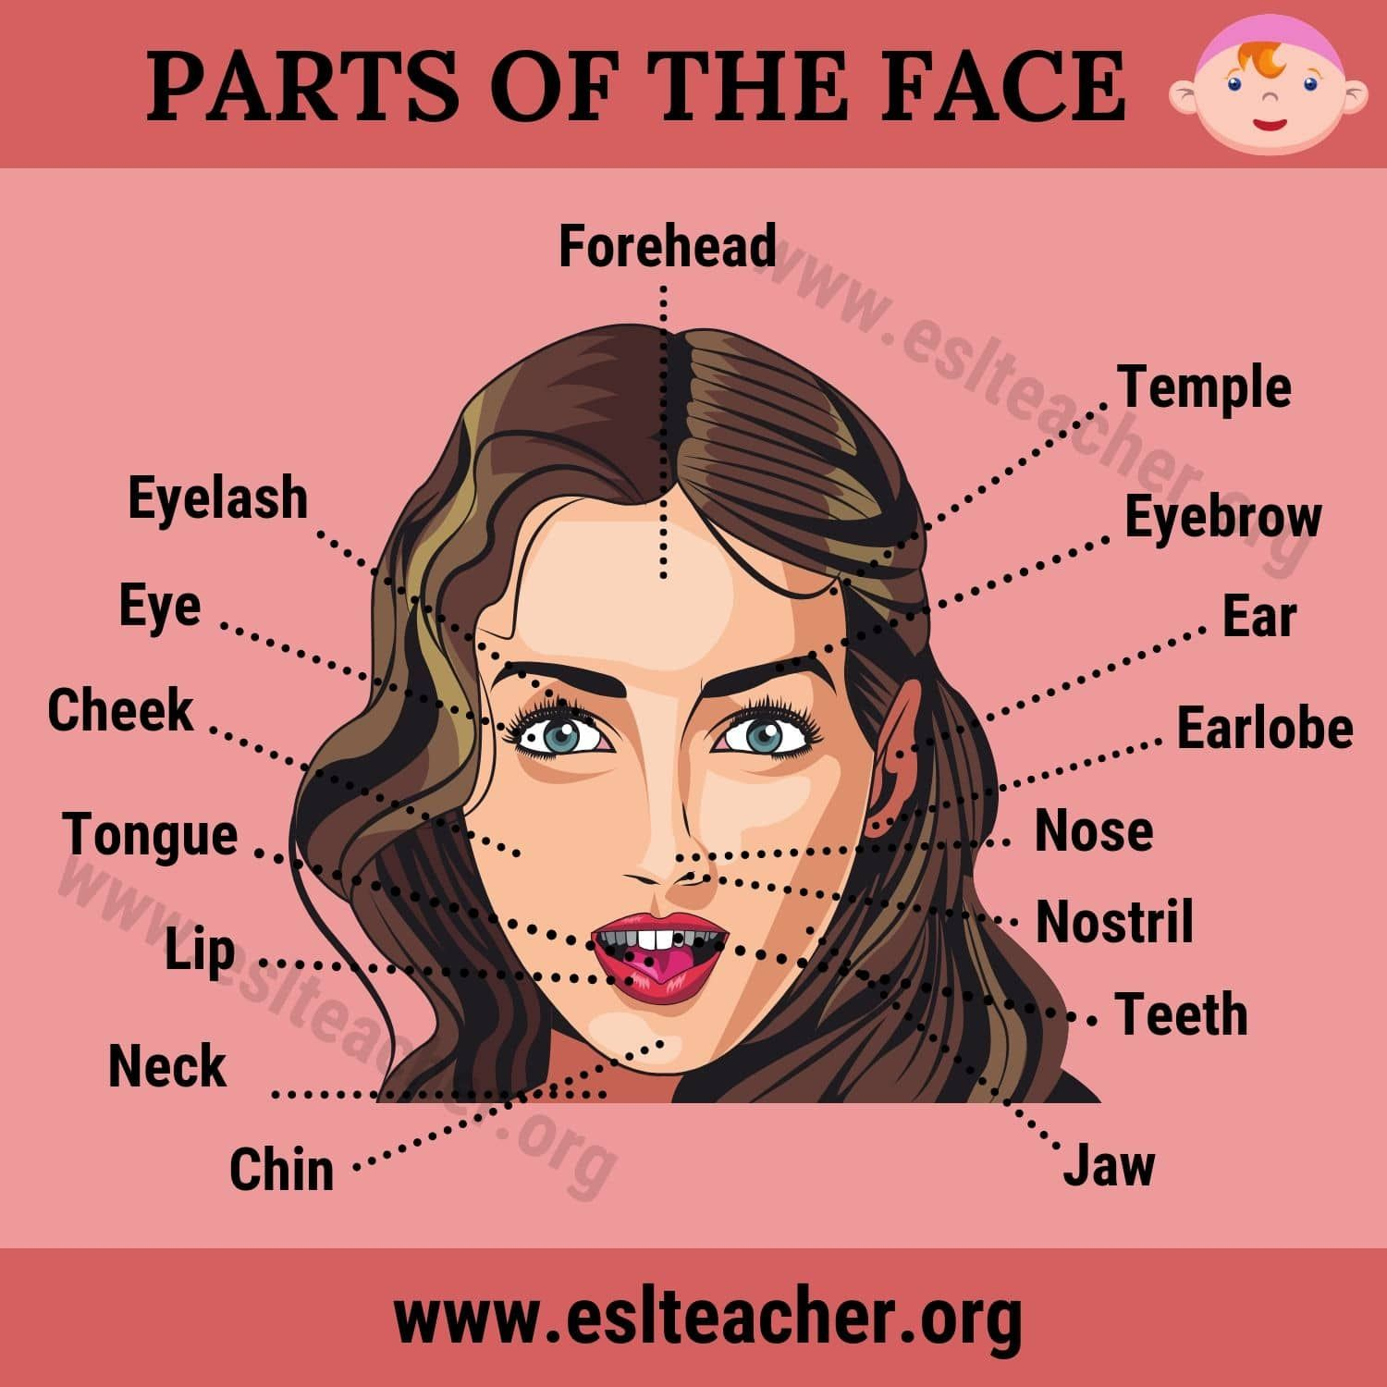
Extension:
Can you improve the similes and metaphors?
His nose was like a mountain. His eyes were like valleys. His forehead was a city. His eyebrows were walls.

