School Closure Daily Planning- Crystal Class Sp 4 Week 2
DATE | Reading | Writing | Mathematics | Topic
Wednesday  3.2.21 | 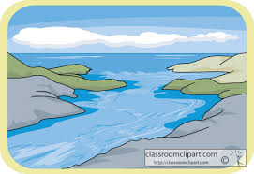  Non-chronological report Rivers  Looking over the text again, highlight/copy out any new or interesting vocabulary or words you think the author has chosen for impact. Write out definitions for new and interesting vocabulary. Challenge: Why did the author choose the words for impact that he/she did?  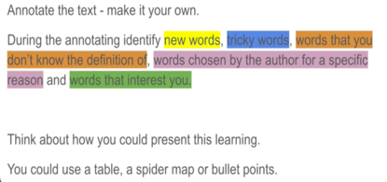  I’ve included a fantastic example of the type of layout you could use. | To investigate more prefixes: Bi-, Trans-, Circum- and Tele-  In this lesson, we investigate and generate rules about the prefixes bi-, trans-, circum- and tele-  https://classroom.thenational.academy/lessons/to-investigate-more-prefixes-bi-trans-circum-and-tele-69gk4c  . | Mixed numbers to improper fractions  Video  https://vimeo.com/500361175  Teaching slides  https://resources.whiterosemaths.com/wp-content/uploads/2021/01/Spr5.5.1-Mixed-numbers-to-improper-fractions.pptx  True or False  https://resources.whiterosemaths.com/wp-content/uploads/2020/01/T-or-F-Year-5-Spring-B2-S3-Mixed-numbers-to-improper-fractions.pdf  Task  https://resources.whiterosemaths.com/wp-content/uploads/2019/12/Y5-Spring-Block-2-WO3-Mixed-numbers-to-improper-fractions-2019.pdf  Answers  https://resources.whiterosemaths.com/wp-content/uploads/2021/01/Y5-Spring-Block-2-ANS3-Mixed-numbers-to-improper-fractions-2019-1.pdf | https://www.loom.com/share/3fc3421056db466580107eaabd236516  Think about the following questions:  What do you like to spend your pocket money on?  What one thing would you buy if you had the money right now?  Have you ever saved up for  something?  Where do you put your money if you want to save it?  When is keeping money in your pocket or a wallet a good idea?  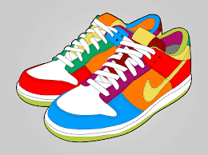  You see some expensive trainers. Do you…  - Save your money until you can afford them?  - Ask your parents many times until they buy them for you?  - Ask for them as a present on your birthday or Christmas?  Offer to do odd jobs around the house to earn the money to buy them?

Geography ideas:
https://www.natgeokids.com/uk/?s=rivers&post_type=
https://www.bbc.co.uk/bitesize/search?q=rivers
English ideas:
https://www.literacyshed.com/story-starters.html
Online dictionary -https://kids.wordsmyth.net/we/
Pobble 365 Writing activities https://www.pobble365.com/
Maths ideas:
Pixl –practise tables using the App
Nrich -https://nrich.maths.org/primary
Worksheets to practise tables: http://www.snappymaths.com/
Keeping active:
Cosmic kids yoga –mainly on Youtube check with an adult
GoNoodle -https://app.gonoodle.com/
The Woodland trust - https://www.woodlandtrust.org.uk/support-us/act/your-school/resources/
Joe Wicks daily work out

