School Closure Daily Planning- Crystal Class - Sp 4 Week 2
DATE | Reading | Writing | Mathematics | Topic
Thursday 4th Mrach | PantoTime!!!  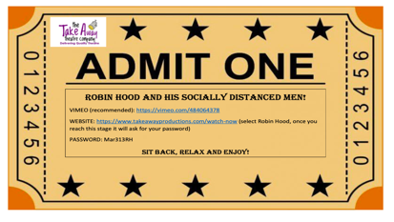 | Join me for a special live zoom get together to share your favourite book or costume.  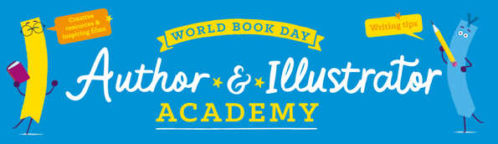  https://www.worldbookday.com/online-masterclasses/  Make your own book  Today you have the opportunity to write and illustrate your own story.  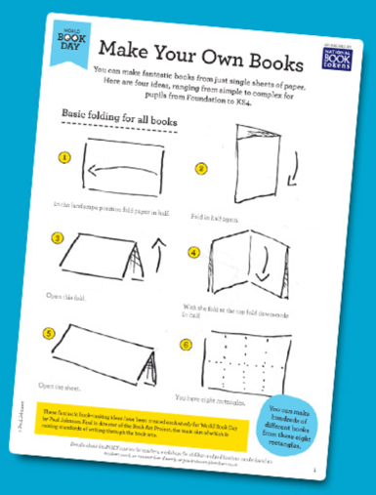 | Number sequences  Video  https://vimeo.com/500361688  Teaching slides  https://resources.whiterosemaths.com/wp-content/uploads/2021/01/Spr5.5.2-Number-sequences.pptx  True or False  https://resources.whiterosemaths.com/wp-content/uploads/2020/01/T-or-F-Year-5-Spring-B2-S4-Number-sequences.pdf  Task  https://resources.whiterosemaths.com/wp-content/uploads/2019/12/Y5-Spring-Block-2-WO4-Number-sequences-2019.pdf  Answers  https://resources.whiterosemaths.com/wp-content/uploads/2019/12/Y5-Spring-Block-2-ANS4-Number-sequences-2019.pdf  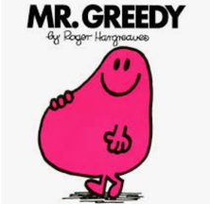 | https://www.loom.com/share/3fec3847529441b3a1524d1248af2711  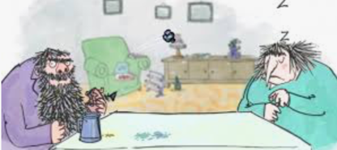  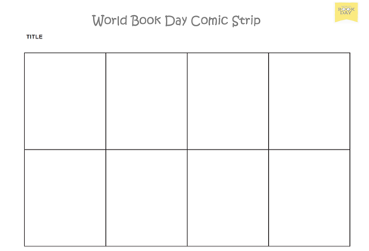  Create a comic strip using different characters from books. I have included a selection you could use.

Geography ideas:
https://www.natgeokids.com/uk/?s=rivers&post_type=
https://www.bbc.co.uk/bitesize/search?q=rivers
English ideas:
https://www.literacyshed.com/story-starters.html
Online dictionary -https://kids.wordsmyth.net/we/
Pobble 365 Writing activities https://www.pobble365.com/
Maths ideas:
Pixl –practise tables using the App
Nrich -https://nrich.maths.org/primary
Worksheets to practise tables: http://www.snappymaths.com/

Keeping active:
Cosmic kids yoga –mainly on Youtube check with an adult
GoNoodle -https://app.gonoodle.com/
The Woodland trust - https://www.woodlandtrust.org.uk/support-us/act/your-school/resources/
Joe Wicks daily work out

