School Closure Daily Planning- Garnet Class
DATE | Reading | Writing | Mathematics | Topic
Thursday 4th March  4.3.21.21  Listen to Chapter 3 from our class story  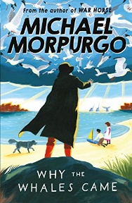 | Answering retrieval and inference questions for the text, The Loch Ness Monster  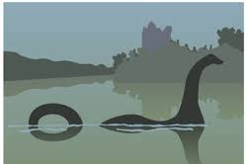  Mrs Duffield recaps on how to find the answers to our questions from a text.  Please follow the link to:  https://www.loom.com/share/58cec94669b24acd9fe8468f7ca71d47 | World Book Day parade and Zoom call.  Please write about your favourite book as a recommendation for the library or for a friend. Can you think about the information you might need?  Use the template to help you.  And/or  Redesign the front cover of a favourite book.  Please use the template to help you. | White Rose  Please watch the video on Equivalent frations (1) and complete the work sheet.  Remember to try your best and if you are finding it tricky just do the first couple of questions.  https://whiterosemaths.com/homelearning/year-4/spring-week-6-number-fractions/  Extension  Please complete the extension question | Pantomime –see the link on SeeSaw

https://www.literacyshed.com/story-starters.html
Online dictionary -https://kids.wordsmyth.net/we/

Maths ideas:
Pixl –practise tables using the App
Nrich -https://nrich.maths.org/primary
Worksheets to practise tables: http://www.snappymaths.com/

Keeping active:
Cosmic kids yoga –mainly on Youtube check with an adult
GoNoodle -https://app.gonoodle.com/
The Woodland trust - https://www.woodlandtrust.org.uk/support-us/act/your-school/resources/
Joe Wicks daily work out

CBBC: has lots of programmes from ‘Horrible Histories’ to ‘Operation Ouch’

