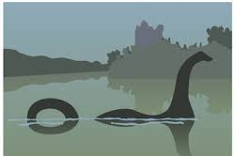
Watch Mrs Duffield’s video to find out how to answer the first two questions. Remember to answer in full and take care with presentation.

Q1. Where is it said that the Loch Ness Monster lives?

Q2. What do you think the word legend in the sub-heading is suggesting?

Q3. How many people visit Loch Ness every year?

Q4. What kind of person might go to the loch to spot Nessie?

Q5. In 1934 how did Robert White create Nessie?

Q6. Why do you think the hunter used a stuffed hippo’s foot as a Nessie footptint?

