School Closure Daily Planning- Crystal Class Sp 4 Week 2
DATE | Reading | SPaG/Writing | Mathematics | Topic
Friday 5th March  Live zoom with Mrs Doe at 9.30am | 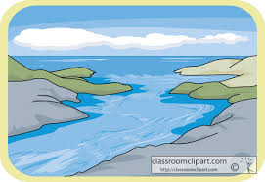  Non-chronological report Rivers  Answer and mark How did you do?  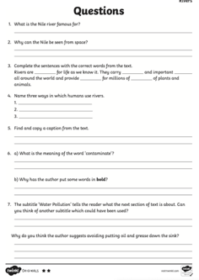  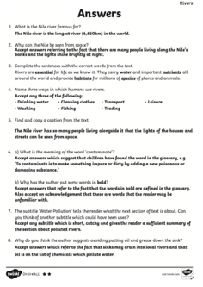 | .  To practise and apply knowledge of more prefixes  In this lesson, we will learn how to spell words containing the prefixes bi-, trans-, circum- and tele-  https://teachers.thenational.academy/units/prefixes-un-dis-mis-in-il-im-ir-re-sub-inter-super-anti-auto-bi-trans-tele-circu#  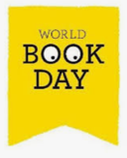  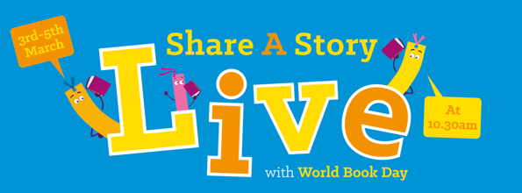  Friday 5th March, 10.30am – Books and the Real World  Starring: Sita Brahmachari, Jess French and Katherine Rundell  Hosted by Jessie Cave, actor and podcaster  https://www.worldbookday.com/event/books-and-the-real-world/#  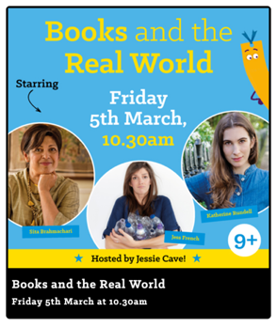 | Compare and order fractions less than 1 (first part of worksheet)  Video  https://vimeo.com/500362215  Teaching slide  https://resources.whiterosemaths.com/wp-content/uploads/2021/01/Spr5.5.3-Compare-and-order-fractions-less-than-1-first-part-of-worksheet.pptx  True or False  https://resources.whiterosemaths.com/wp-content/uploads/2020/01/T-or-F-Year-5-Spring-B2-S5-Compare-and-order-fractions-less-than-1.pdf  Task  https://resources.whiterosemaths.com/wp-content/uploads/2019/12/Y5-Spring-Block-2-WO5-Compare-and-order-fractions-less-than-1-2019.pdf  Answer  https://resources.whiterosemaths.com/wp-content/uploads/2020/08/Y5-Spring-Block-2-ANS5-Compare-and-order-fractions-less-than-1-2019.pdf | 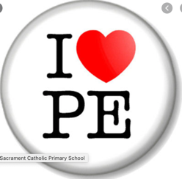  PE  Have a go at this work out. It’s quite full on, make sure you have comfy clothing and a glass of water at the ready.  https://www.youtube.com/watch?v=O8XvnrZNwv0&feature=emb_logo  Then relax after all that hard work, with this Cosmic Kids yoga video based on The Masked Singer:  https://www.youtube.com/watch?v=_hB7yYxX0Ag&list=PL8snG khBF7nhEquR7wXbzIXjFrlXsze_H&index=23  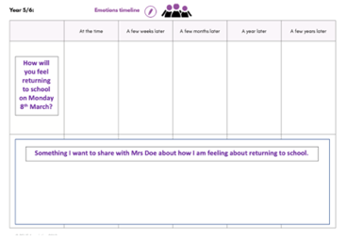  https://www.loom.com/share/e37195141e8640bb8209c3cdfa2cbbff

Other useful websites:
Geography ideas:
https://www.natgeokids.com/uk/?s=rivers&post_type=
https://www.bbc.co.uk/bitesize/search?q=rivers
English ideas:
https://www.literacyshed.com/story-starters.html
Online dictionary -https://kids.wordsmyth.net/we/
Pobble 365 Writing activities https://www.pobble365.com/
Maths ideas:
Pixl –practise tables using the App
Nrich -https://nrich.maths.org/primary
Worksheets to practise tables: http://www.snappymaths.com/

Keeping active:
Cosmic kids yoga –mainly on Youtube check with an adult
GoNoodle -https://app.gonoodle.com/
The Woodland trust - https://www.woodlandtrust.org.uk/support-us/act/your-school/resources/
Joe Wicks daily work out

CBBC: has lots of programmes from ‘Horrible Histories’ to ‘Operation Ouch’

