School Closure Daily Planning- Garnet Class
DATE | Reading | Writing | Mathematics | Topic
Wednesday 3rd March  3.3.21  Story listen to the next instalment on SeeSaw  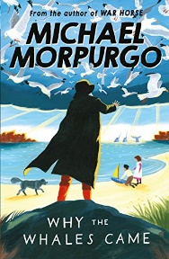 | Identify and understand new words.  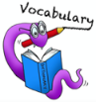  Can you go through the text ‘The Loch Ness Monster’ and highlight 4-5 key words that you are interested in finding out about.  Can you use a dictionary to find and write the definitions and identify the word class. Can you write the word in a meaningful sentence too?  Online dictionary:  https://kids.wordsmyth.net/we/ | Persuasive letter  Today you are going to think about and then write a persuasive letter. Can you look at the worksheet and follow the instructions. | White rose Maths  Equivalent fractions (2) –revision  Please complete the work sheets  https://whiterosemaths.com/homelearning/year-4/spring-week-6-number-fractions/  Please complete the the Flashback  Extension  Please complete the question –remember to cover the answers. | Revise the colours we practised last week and practise saying your favourite colour too.  https://www.loom.com/share/e422f8cde0634ea5b004ad95d6ddae87

https://www.literacyshed.com/story-starters.html
Online dictionary https://kids.wordsmyth.net/we/

Maths ideas:
Pixl –practise tables using the App
Nrich -https://nrich.maths.org/primary
Worksheets to practise tables: http://www.snappymaths.com/

Keeping active:
Cosmic kids yoga –mainly on Youtube check with an adult
GoNoodle -https://app.gonoodle.com/
The Woodland trust - https://www.woodlandtrust.org.uk/support-us/act/your-school/resources/
Joe Wicks daily work out

CBBC: has lots of programmes from ‘Horrible Histories’ to ‘Operation Ouch’

