School Closure Daily Planning- Garnet Class
DATE | Reading | Writing | Mathematics | Topic
Tuesday 2nd March  2.3.21  Listen to the class story with Mrs Duffield –on SeeSaw  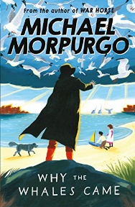 | Ask questions to understand the text.  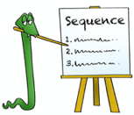  ‘ The Loch Ness Monster’  Can you discuss the text with someone near you?  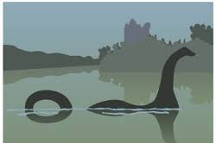  What is the text about?  Can you highlight any unknown words? What do they mean?  What kind of text is it?  How do you know?  What do you like/dislike about the text?  Can you find one key fact from each paragraph? Can you hightlight or underline your key fact? | 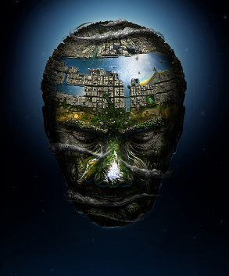  Can you finish the poem using similes and metaphors?  Listen to Mrs Duffield recap on metaphors and similes and find out how to write your own poem using the incredible pictue called ‘Head of the World’  https://www.loom.com/share/178b2d904008411197e3eb0f97308300 | White rose maths  Equivalent fractions (1)  Please can you watch the video and complete the work sheets. If you are finding the work challenging then try and do as much as you can.  https://whiterosemaths.com/homelearning/year-4/spring-week-5-number-fractions/  True or false and extension  Please complete the True or false and the extension. | Exploring the human and physical Geography of Edinburgh and land use of the Islands.  Please follow the link to:  https://www.loom.com/share/e83bf9b50a2842da9b0c8a18eda32e6e  Baking Scottish short bread  You will need to ask an adult to help you with this recipe.  This is a traditional Scottish biscuit and is famous all around the world  See the recipe card  Draw the Loch Ness Monster  Follow the link to:  https://www.youtube.com/watch?v=EPherk_f948

Geography ideas:
BBC Bitesize Geography
https://www.3dgeography.co.uk/geography-topic
https://www.sciencekids.co.nz/sciencefacts/countries/england.html
https://www.ducksters.com/geography/country/united_kingdom.php

English ideas:

https://www.literacyshed.com/story-starters.html
Online dictionary -https://kids.wordsmyth.net/we/

Maths ideas:
Pixl –practise tables using the App
Nrich -https://nrich.maths.org/primary
Worksheets to practise tables: http://www.snappymaths.com/

Keeping active:
Cosmic kids yoga –mainly on Youtube check with an adult
GoNoodle -https://app.gonoodle.com/
The Woodland trust - https://www.woodlandtrust.org.uk/support-us/act/your-school/resources/
Joe Wicks daily work out

CBBC: has lots of programmes from ‘Horrible Histories’ to ‘Operation Ouch’

