The Mission on the Moon
During their time on the Moon, the Apollo 11 astronauts had a lot to do. First, they took photographs of the Moon’s surface and collected lunar samples. This took three and a half minutes. The map below shows the landing area, where these activities took place.
SWC: solar wind experiment 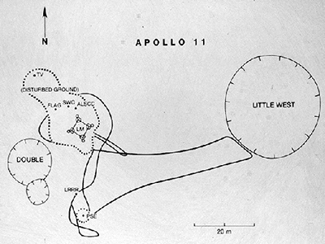 LM: landing module.
Map of the landing area
Next, they set up an experiment to identify and measure solar wind particles. To do this they put a large sheet of foil on a pole, facing the sun.
The astronauts also put the United States flag on the Moon’s surface. It was rectangular and measured 1m by almost 2m. To keep it open, in the lunar vacuum, it had a support along the top.
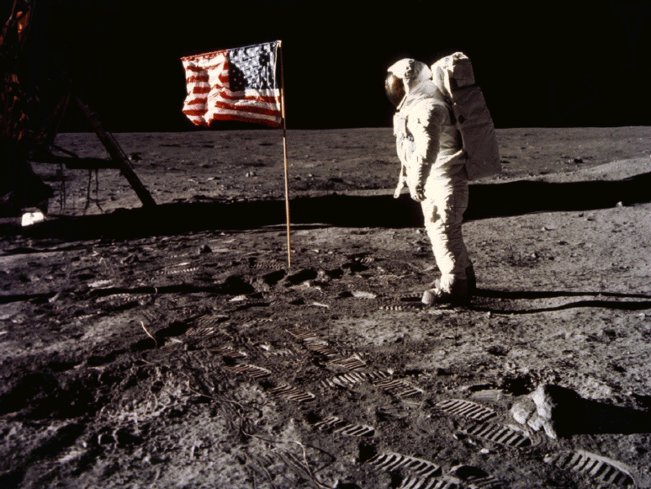
Finally, the astronauts took some more samples from the Moon’s surface and took photographs of the view from the Moon.
After two and a half hours, the two astronauts ended their mission to the Moon, leaving behind a plaque. It said:
"Here Men From Planet Earth
First Set Foot Upon The Moon
July 1969 A.D.
We Came In Peace For All Mankind"

