The Mission on the Moon
On the Moon, the Apollo 11 astronauts had a lot to do. First, they took photographs of the Moon’s surface and then collected lunar samples.
SWC: solar wind experiment 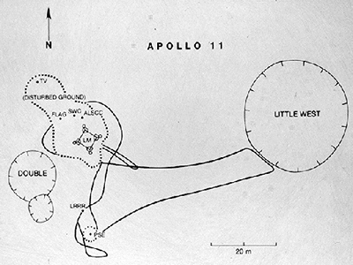 LM: landing module.
Map of the landing area
Next, they set up an experiment to measure solar wind.
The astronauts also put the United States flag on the Moon’s surface. To keep it open, it had a support along the top.
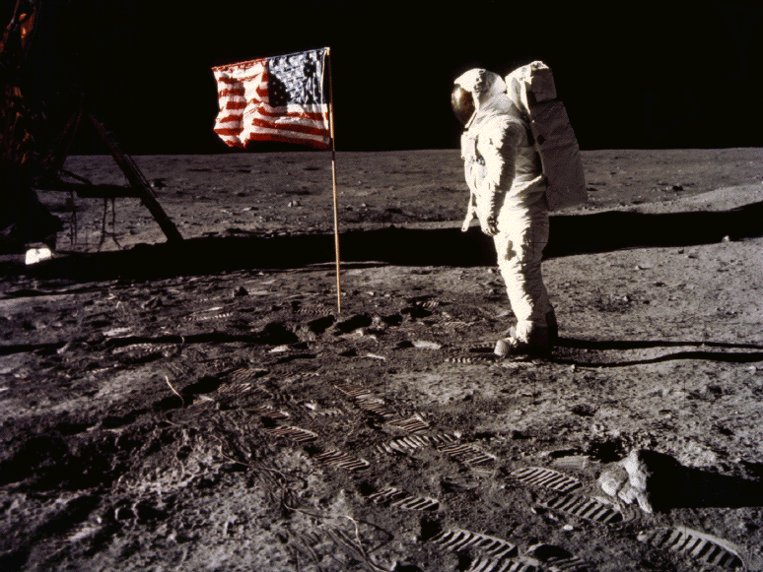
Finally, the astronauts took some more samples from the Moon’s surface and took photographs of the view from the Moon.
When the two astronauts ended their mission, after two and a half hours, they left behind a plaque. It said:
"Here Men From Planet Earth
First Set Foot Upon The Moon
July 1969 A.D.
We Came In Peace For All Mankind"

