School Closure Daily Planning- Crystal Class Week 5
DATE | Reading | Writing | Mathematics | Topic
Wednesday  3.2.21  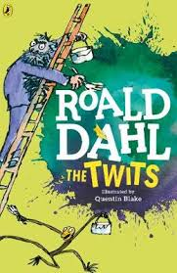  Also listen to story time with Mrs Doe.  https://www.loom.com/share/8d17c2039b73412692476c3aa29b0ac2 | Watch the online recorded lesson of Mrs Doe.  https://www.loom.com/share/72aeba62d82a4523ab477e3e65097167  Looking over the text again, highlight/copy out any new or interesting vocabulary or words you think the author has chosen for impact. Write out definitions for new and interesting vocabulary. Challenge: Why did the author choose the words for impact that he/she did? | https://www.loom.com/share/9083d087e14948c0afb249153fcf068a  Watch the online recorded lesson of Mrs Doe.  Continue to plan your myth today you will be thinking about the object your character is after and the problem the main character comes across whilst on their journey.  What problems will they encounter?  Who do they meet on their journey?  What have they been asked to solve?  What object are they looking for or trying to get and why?  What happens? | 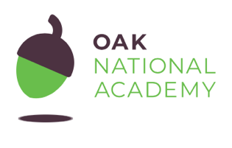  Calculating time intervals on timetables  Today we will be sharing efficient methods for calculating the time intervals listed on timetables. By using the methods modelled, we will be able to identify missing information on incomplete timetables.  Click on the link and work through the introductory quiz, the video, the worksheet and then the final quiz.  https://classroom.thenational.academy/lessons/calculating-time-intervals-on-timetables-c4w64c  Activity sheet linked to the Oak Academy video  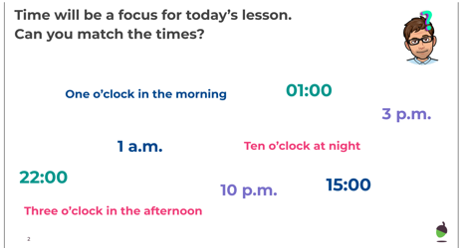  -  True or False  https://resources.whiterosemaths.com/wp-content/uploads/2019/12/T-or-F-Year-5-S5-Two-way-tables.pdf  Activity sheet  https://resources.whiterosemaths.com/wp-content/uploads/2019/10/Y5-Autumn-Block-3-WO5-Two-way-tables-2019.pdf  Answers  https://resources.whiterosemaths.com/wp-content/uploads/2020/10/Y5-Autumn-Block-3-ANS5-Two-way-tables.pdf | 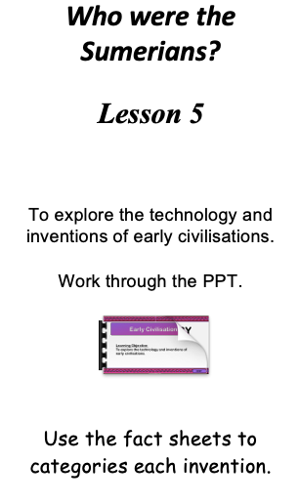  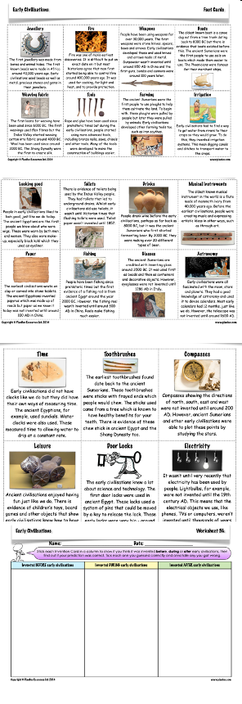

History ideas:
https://www.bbc.co.uk/teach/class-clips-video/history-ks2-introducing-ancient-sumer/zmgnvk7
https://www.theschoolrun.com/homework-help/ancient-sumer-and-mesopotamia
CBBC: has lots of programmes from ‘Horrible Histories’ to ‘Operation Ouch’

English ideas:
https://www.literacyshed.com/story-starters.html
Online dictionary -https://kids.wordsmyth.net/we/
Pobble 365 Writing activities https://www.pobble365.com/
Maths ideas:
Pixl –practise tables using the App
Nrich -https://nrich.maths.org/primary
Worksheets to practise tables: http://www.snappymaths.com/
Keeping active:
Cosmic kids yoga –mainly on Youtube check with an adult
GoNoodle -https://app.gonoodle.com/
The Woodland trust - https://www.woodlandtrust.org.uk/support-us/act/your-school/resources/
Joe Wicks daily work out

