School Closure Daily Planning- Crystal Class Sp 4 Week 1
DATE | Reading | Writing | Mathematics | Topic
Wednesday  24.2.21 | 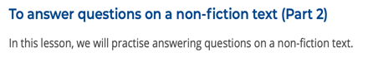  Rushing Rivers by Kingfisher  https://teachers.thenational.academy/units/rushing-rivers-by-kingfisher-ea96#  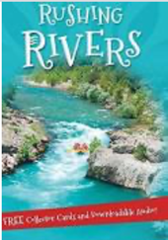 | What is a non-chronological report?  Watch the BBC video.  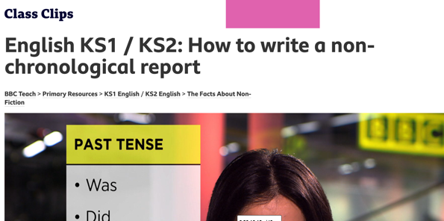  https://www.bbc.co.uk/teach/class-clips-video/english-ks1-ks2-how-to-write-a-non-chronological-report/zvbtscw  BBC journalist Sonali Shah explains how writing non-chronological reports requires an understanding of the planning, writing and drafting process.  Sonali takes you through the process from start to finish; identifying the key features of non-chronological writing and emphasising the importance of researching, drafting and proof-reading in her job as a journalist.  She also explains how important it is to engage the reader by using appropriate vocabulary.  Questions:  What is needed to write a good non-chronological report?  What features are required? Can you remember any technical language to describe the features?  When writing a non-chronological report, what format should it take?  Come up with a list of the criteria required to write a successful non-chronological report.  . | 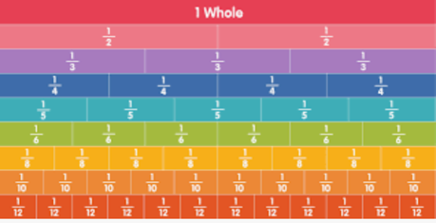  Recap Equivalent fractions  Video  https://vimeo.com/498327458  Teaching slides  https://resources.whiterosemaths.com/wp-content/uploads/2021/01/Spr5.4.2-Equivalent-fractions-1.pptx  True or False  https://resources.whiterosemaths.com/wp-content/uploads/2020/01/T-or-F-Year-4-Spring-B3-S2-Equivalent-Fractions-1.pdf  Work sheet  https://resources.whiterosemaths.com/wp-content/uploads/2019/12/Y4-  Spring-Block-3-WO2-Equivalent-fractions-1-2019.pdf  Answers  https://resources.whiterosemaths.com/wp-content/uploads/2019/12/Y4-Spring-Block-3-ANS2-Equivalent-fractions-1-2019.pdf | LENT – Watch Mrs Wicheard’s assembly about lent.  Also go through the Lent PPT and complete the ‘Thinking about Lent’ activity sheet. As an extra activity, use your new knowledge on Lent to write a poem.  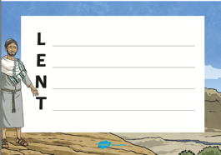  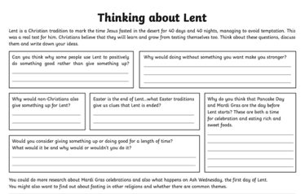  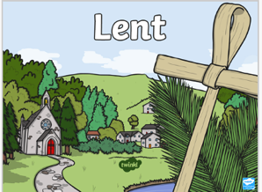

Geography ideas:
https://www.natgeokids.com/uk/?s=rivers&post_type=
https://www.bbc.co.uk/bitesize/search?q=rivers
English ideas:
https://www.literacyshed.com/story-starters.html
Online dictionary -https://kids.wordsmyth.net/we/
Pobble 365 Writing activities https://www.pobble365.com/
Maths ideas:
Pixl –practise tables using the App
Nrich -https://nrich.maths.org/primary
Worksheets to practise tables: http://www.snappymaths.com/
Keeping active:
Cosmic kids yoga –mainly on Youtube check with an adult
GoNoodle -https://app.gonoodle.com/
The Woodland trust - https://www.woodlandtrust.org.uk/support-us/act/your-school/resources/
Joe Wicks daily work out

