School Closure Daily Planning- Crystal Class Week 6
DATE | Reading | Writing | Mathematics | Topic
Wednesday  10.2.21  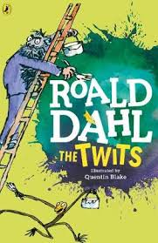  Also listen to story time with Mrs Doe. | Looking over the text again, highlight/copy out any new or interesting vocabulary or words you think the author has chosen for impact. Write out definitions for new and interesting vocabulary. Challenge: Why did the author choose the words for impact that he/she did?  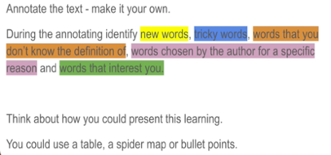  I’ve included a fantastic example of the type of layout you could use.  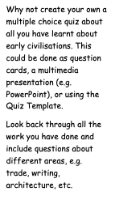 | https://www.loom.com/share/42507b4c1afd4b5f8f6a75314590ca43  Watch the online recorded lesson of Mrs Doe.  Either…  - Continue to write your myth.  Then…  - Proof read and edit your myth. If you haven’t got a purple polishing pen use any colour.  Remember..”Put your pen in the air because you care!”  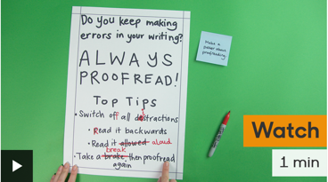  https://www.bbc.co.uk/bitesize/topics/zr6bxyc/articles/z7vhsrd | Video  https://vimeo.com/464197707  True or False  https://resources.whiterosemaths.com/wp-content/uploads/2019/12/T-or-F-Year-5-S2-Draw-line-graphs.pdf  PPT  https://resources.whiterosemaths.com/wp-content/uploads/2020/11/Aut5.6.5-Draw-line-graphs.pptx  Work sheet  https://resources.whiterosemaths.com/wp-content/uploads/2019/09/Y5-Autumn-Block-3-WO2-Draw-line-graphs-2019.pdf  Answers  https://resources.whiterosemaths.com/wp-content/uploads/2020/10/Y5-Autumn-Block-3-ANS2-Draw-line-graphs.pdf | Who were the Sumerians?  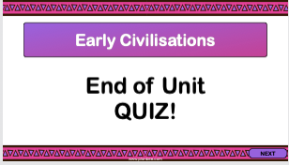  Complete the end of topic quiz.  You could use this template.  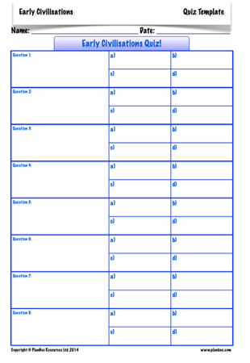

History ideas:
https://www.bbc.co.uk/teach/class-clips-video/history-ks2-introducing-ancient-sumer/zmgnvk7
https://www.theschoolrun.com/homework-help/ancient-sumer-and-mesopotamia
CBBC: has lots of programmes from ‘Horrible Histories’ to ‘Operation Ouch’

English ideas:
https://www.literacyshed.com/story-starters.html
Online dictionary -https://kids.wordsmyth.net/we/
Pobble 365 Writing activities https://www.pobble365.com/
Maths ideas:
Pixl –practise tables using the App
Nrich -https://nrich.maths.org/primary
Worksheets to practise tables: http://www.snappymaths.com/
Keeping active:
Cosmic kids yoga –mainly on Youtube check with an adult
GoNoodle -https://app.gonoodle.com/
The Woodland trust - https://www.woodlandtrust.org.uk/support-us/act/your-school/resources/
Joe Wicks daily work out

