School Closure Daily Planning- Crystal Class Week 6
DATE | Reading | Writing | Mathematics | Topic
Tuesday  9.2.21  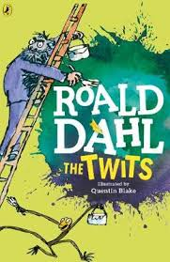  Also listen to story time with Mrs Doe. | Re-read the text from yesterday. Annotate on the text thinking about how it should sound to the audience like we do in class. Can you read it to someone in your family?  Give a performance. | Today you will pull all of your plans  together to write your own myth.  enjoy going through the PPT to  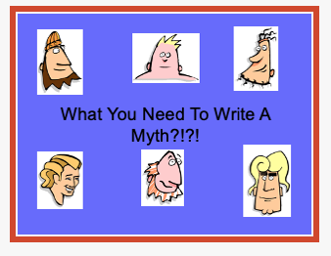  get ideas for yours.  I’ve included a planning sheet to  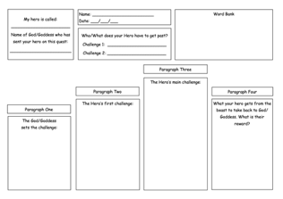  help you. | Video  https://vimeo.com/464199069  True or False  https://resources.whiterosemaths.com/wp-content/uploads/2019/12/T-or-F-Year-5-S1-Read-and-interpret-line-graphs.pdf  Work sheet  https://resources.whiterosemaths.com/wp-content/uploads/2019/09/Y5-Autumn-Block-3-WO1-Read-and-interpret-line-graphs-2019.pdf  Answer  https://resources.whiterosemaths.com/wp-content/uploads/2020/10/Y5-Autumn-Block-3-ANS1-Read-and-interpret-line-graphs.pdf | 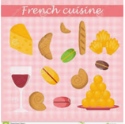  Watch the online recorded lesson of Mrs Harris.  https://www.loom.com/share/b463ad9ac9eb4a56b83c7f1e47dbe432  Then do the French food and drink activity.  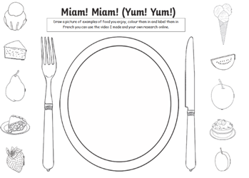

History ideas:
https://www.bbc.co.uk/teach/class-clips-video/history-ks2-introducing-ancient-sumer/zmgnvk7
https://www.theschoolrun.com/homework-help/ancient-sumer-and-mesopotamia

English ideas:
https://www.literacyshed.com/story-starters.html
Online dictionary -https://kids.wordsmyth.net/we/
Pobble 365 Writing activities https://www.pobble365.com/
Maths ideas:
Pixl –practise tables using the App
Nrich -https://nrich.maths.org/primary
Worksheets to practise tables: http://www.snappymaths.com/

Keeping active:
Cosmic kids yoga –mainly on Youtube check with an adult
GoNoodle -https://app.gonoodle.com/
The Woodland trust - https://www.woodlandtrust.org.uk/support-us/act/your-school/resources/
Joe Wicks daily work out

CBBC: has lots of programmes from ‘Horrible Histories’ to ‘Operation Ouch’

