School Closure Daily Planning- Crystal Class - Sp 4 Week 1
DATE | Reading | Writing | Mathematics | Topic
Tuesday  23.2.21 | 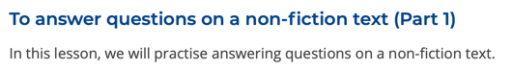  https://www.loom.com/share/bae3d2053e724b6d9653ff144d47ed91  https://teachers.thenational.academy/units/rushing-rivers-by-kingfisher-ea96#  Rushing Rivers by Kingfisher | COLD WRITE  Your task is to write a sports  non-chronological report about our  favourite team game – Bench Ball.  Use the headings:  - Introduction  - Aim of the game  - Rules  - Equpiment  - Court/pitch  - Conclusion  - Did you know?  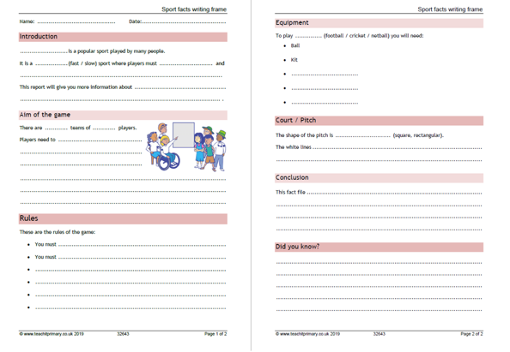 | Recap What is a fraction?  Video  https://vimeo.com/498327271  Teaching slides  https://resources.whiterosemaths.com/wp-content/uploads/2021/01/Spr5.4.1-What-is-a-fraction.pptx  True or False  https://resources.whiterosemaths.com/wp-content/uploads/2020/01/T-or-F-Year-4-Spring-B3-S1-What-is-a-fraction.pdf  Work sheet  https://resources.whiterosemaths.com/wp-content/uploads/2019/12/Y4-Spring-Block-3-WO1-What-is-a-fraction_-2019.pdf  Answer  https://resources.whiterosemaths.com/wp-content/uploads/2021/02/Y4-Spring-Block-3-ANS1-What-is-a-fraction_-2019.pdf | Where in the world is French spoken?  This term we are learning about the countries and culture of France and the French language we will start with this question…  Where in the world is French spoken?  Read through the pdf version of our PowerPoint and then create a fact file about what you have learnt. You should include bullet points, subheading and drawings.

Geography ideas:
https://www.natgeokids.com/uk/?s=rivers&post_type=
https://www.bbc.co.uk/bitesize/search?q=rivers
English ideas:
https://www.literacyshed.com/story-starters.html
Online dictionary -https://kids.wordsmyth.net/we/
Pobble 365 Writing activities https://www.pobble365.com/
Maths ideas:
Pixl –practise tables using the App
Nrich -https://nrich.maths.org/primary
Worksheets to practise tables: http://www.snappymaths.com/

Keeping active:
Cosmic kids yoga –mainly on Youtube check with an adult
GoNoodle -https://app.gonoodle.com/
The Woodland trust - https://www.woodlandtrust.org.uk/support-us/act/your-school/resources/
Joe Wicks daily work out

CBBC: has lots of programmes from ‘Horrible Histories’ to ‘Operation Ouch’

