School Closure Daily Planning- Crystal Class Week 5
DATE | Reading | Writing | Mathematics | Topic
Tuesday  2.2.21  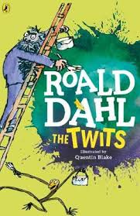  Also listen to story time with Mrs Doe.  https://www.loom.com/share/8d17c2039b73412692476c3aa29b0ac2 | 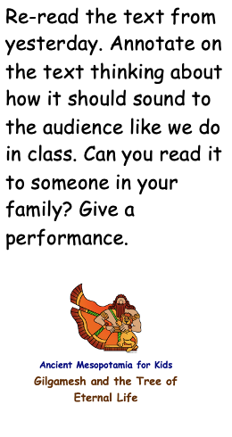 | Watch the online recorded  lesson of Mrs Doe.  https://www.loom.com/share/0d8b8ca7c54c4e278f7222a3fc3dd817  Use the  information to answer whether  the statements are TRUE, A MYTH OR  UNKNOWN.  Why do you know this?  Show me evidence.  Think about how you could present  your results.  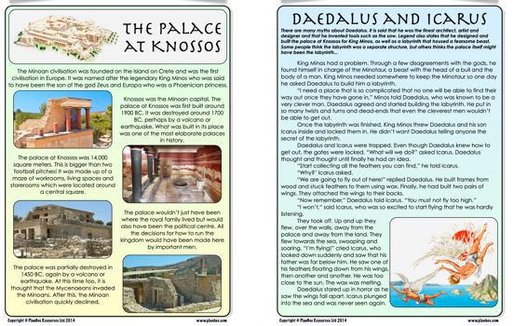  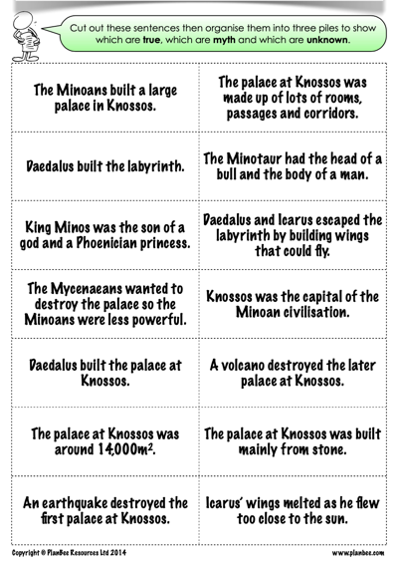 | Reading timetables  Today we will be introducing timetables, what they can tell us and the skills we require to use them accurately when interpreting the information they possess. We will then be using a timetable to help respond to a series of questions and requests as an example of real life context.  Click on the link and work through the introductory quiz, the video, the worksheet and then the final quiz.  https://classroom.thenational.academy/lessons/reading-timetables-6wwkgt  Activity sheet linked to the Oak Academy video  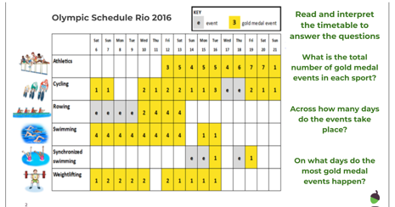  True or False  https://resources.whiterosemaths.com/wp-content/uploads/2019/12/T-or-F-Year-5-S4-Read-and-interpret-tables.pdf  Activity sheet  https://resources.whiterosemaths.com/wp-content/uploads/2019/10/Y5-Autumn-Block-3-WO4-Read-and-interpret-tables-2019.pdf  Answers  https://resources.whiterosemaths.com/wp-content/uploads/2020/10/Y5-Autumn-Block-3-ANS4-Read-and-interpret-tables.pdf | Watch the online recorded lesson of Mrs Harris.  Learning colours in french  https://www.loom.com/share/c7743722027f40b085ffd188b08c1578  Then draw a picture with all the colours from the film then on your picture label the objects you have coloured with the correct colour in French.  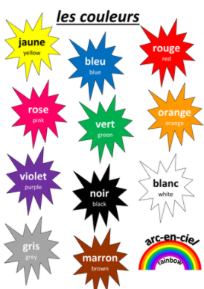  Rewind the video to get the correct spelling.

History ideas:
https://www.bbc.co.uk/teach/class-clips-video/history-ks2-introducing-ancient-sumer/zmgnvk7
https://www.theschoolrun.com/homework-help/ancient-sumer-and-mesopotamia

English ideas:
https://www.literacyshed.com/story-starters.html
Online dictionary -https://kids.wordsmyth.net/we/
Pobble 365 Writing activities https://www.pobble365.com/
Maths ideas:
Pixl –practise tables using the App
Nrich -https://nrich.maths.org/primary
Worksheets to practise tables: http://www.snappymaths.com/

Keeping active:
Cosmic kids yoga –mainly on Youtube check with an adult
GoNoodle -https://app.gonoodle.com/
The Woodland trust - https://www.woodlandtrust.org.uk/support-us/act/your-school/resources/
Joe Wicks daily work out

CBBC: has lots of programmes from ‘Horrible Histories’ to ‘Operation Ouch’

