School Closure Daily Planning- Crystal Class Week 5
DATE | Reading | Writing | Mathematics | Topic
Thursday 4.2.21  Also listen to story time with Mrs Doe.  https://www.loom.com/share/8d17c2039b73412692476c3aa29b0ac2 | Answer the following questions on our text.  https://www.loom.com/share/fffd46527c0d4d48bd97c07d81a0a1fc  A little different this week. Your task is to write the questions for this text that other members in Crystal Class will answer tomorrow. Try to include:  - Multiple Choice (tick or circle)  - Ordering Events by Numbering  - True or False  - Matching  - Sequencing  - Join the definition – you could use your learning from Wednesday for this question.  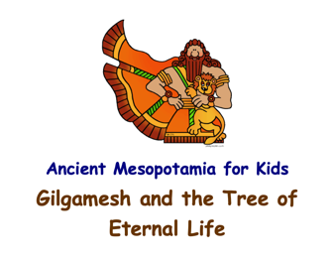  - What does a certain word mean? | Writing the resolution – continue to plan your myth.  How will the problem be resolved…sorted?  The resolution must tie up all of the loose ends.  A bit of a challenge – within your resolution can you give the reader a sense that the lives of the characters continue. | 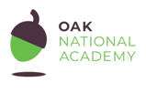  Timetables questions  Today we will be exploring bus and train timetables, using our skills to interpret the information to answer a range of questions as well as generating our own questions to match the information provided. We will also be looking once again at the how the strategy of an empty number line can help us calculate time intervals with the assistance of some teacher modelling.  Click on the link and work through the introductory quiz, the video, the worksheet and then the final quiz.  https://classroom.thenational.academy/lessons/timetables-questions-60rkar  Activity sheet linked to the Oak Academy video  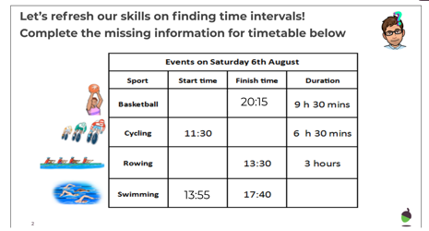  True or False  https://resources.whiterosemaths.com/wp-content/uploads/2019/12/T-or-F-Year-5-S6-Timetables.pdf  Activity sheet  https://resources.whiterosemaths.com/wp-content/uploads/2019/09/Y5-Autumn-Block-3-WO6-Timetables-2019.pdf  Answers  https://resources.whiterosemaths.com/wp-content/uploads/2020/10/Y5-Autumn-Block-3-ANS6-Timetables.pdf | Who were the Sumerians?  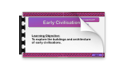  Lesson 6  Have a look at the pictures of the ancient settlements on the PPT.  They are pretty amazing!  Think of eight questions you would like to know the answer to, then use different sources to help you find the answers.  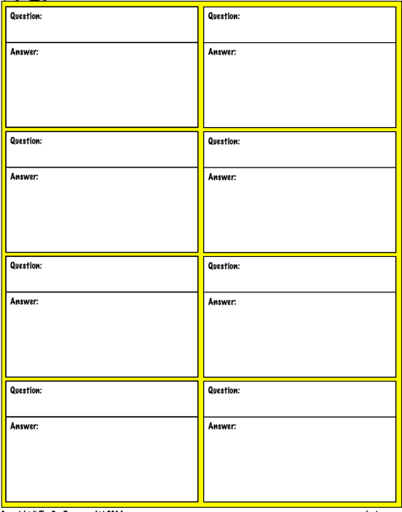

English ideas:
https://www.literacyshed.com/story-starters.html
Online dictionary -https://kids.wordsmyth.net/we/
Pobble 365 Writing activities https://www.pobble365.com/
Maths ideas:
Pixl –practise tables using the App
Nrich -https://nrich.maths.org/primary
Worksheets to practise tables: http://www.snappymaths.com/

Keeping active:
Cosmic kids yoga –mainly on Youtube check with an adult
GoNoodle -https://app.gonoodle.com/
The Woodland trust - https://www.woodlandtrust.org.uk/support-us/act/your-school/resources/
Joe Wicks daily work out

CBBC: has lots of programmes from ‘Horrible Histories’ to ‘Operation Ouch’

