School Closure Daily Planning- Crystal Class - Sp 4 Week 1
DATE | Reading | Writing | Mathematics | Topic
Thursday 25th February | 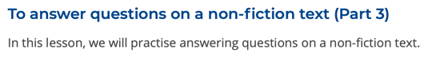  Rushing Rivers by Kingfisher  https://teachers.thenational.academy/units/rushing-rivers-by-kingfisher-ea96#  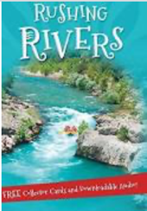 | Features of a non-chronological report  Watch the online recorded lesson of Mrs Doe.  https://www.loom.com/share/57d2fc58dd3f4348a2eddd7ff74a00de  Today you will be comparing your criteria with our non-chronological checklist.  How did you get on?  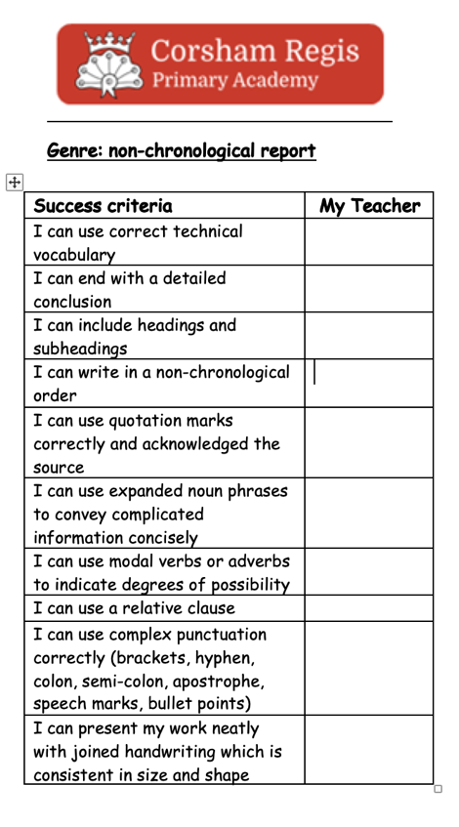  Using the combination of yours and mine, look through the two non-chronological reports and identify the features. | Equivalent fractions  Video  https://vimeo.com/498327611  Teaching slides  https://resources.whiterosemaths.com/wp-content/uploads/2021/01/Spr5.4.3-Equivalent-fractions.pptx  True and False  https://resources.whiterosemaths.com/wp-content/uploads/2020/01/T-or-F-Year-5-Spring-B2-S1-Equivalent-fractions.pdf  Work sheet  https://resources.whiterosemaths.com/wp-content/uploads/2019/12/Y5-Spring-Block-2-WO1-Equivalent-fractions-2019.pdf  Answers  https://resources.whiterosemaths.com/wp-content/uploads/2019/12/Y5-Spring-Block-2-ANS1-Equivalent-fractions-2019.pdf | PSHE  I have thought about how money affects the way I live.  Introduction  Think about these questions:  - What makes you happy?  - When and where are you happiest?  - Do the things that make you happy need money?  - What do we mean by being ‘rich’?  - What amount of money would make you rich?  - Is it better to be rich or happy?  - Can being rich make you happy/happier?  Activity 1:  Discuss what a ‘good day’ is. What would a good day feel like?  How would they know that it had been a good day?  Make a list of what makes a good day.  Activity 2:  Design two weekend timetable of fun activities. One timetable a weekend of ‘fun for free’ and the other timetable with an endless budget.  Think about which of the weekends you would prefer and why.  Are the activities we pay for always the best?  KEY QUESTIONS  - What makes you happy?  - What does it mean to be rich?  - Does money always help you become happier?  - Can you be happy without money?

Geography ideas:
https://www.natgeokids.com/uk/?s=rivers&post_type=
https://www.bbc.co.uk/bitesize/search?q=rivers
English ideas:
https://www.literacyshed.com/story-starters.html
Online dictionary -https://kids.wordsmyth.net/we/
Pobble 365 Writing activities https://www.pobble365.com/
Maths ideas:
Pixl –practise tables using the App
Nrich -https://nrich.maths.org/primary
Worksheets to practise tables: http://www.snappymaths.com/

Keeping active:
Cosmic kids yoga –mainly on Youtube check with an adult
GoNoodle -https://app.gonoodle.com/
The Woodland trust - https://www.woodlandtrust.org.uk/support-us/act/your-school/resources/
Joe Wicks daily work out

