School Closure Daily Planning- Crystal Class Week 6
DATE | Reading | Writing | Mathematics | Topic
Thursday 11th February  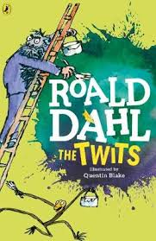  Listen to story time with Mrs Doe. | 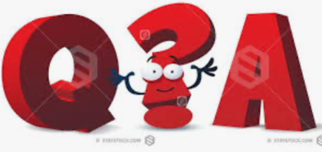  Your questions were so good last week I thought we could do it again.  Your task is to write the questions for this text that other members in Crystal Class will answer tomorrow. Try to include:  - Multiple Choice (tick or circle)  - Ordering Events by Numbering  - True or False  - Matching  - Sequencing  - Join the definition – you could use your learning from Wednesday for this question.  - What does a certain word mean? | Publish your myth by writing it up in your very best handwriting or type it up if you have access to a computer. Think about how you will lay it out with paragraphs and room for a boreder and illustrations.  Remember to make sure you copy your corrections carefully.  Now it’s time to illustrate your myth.  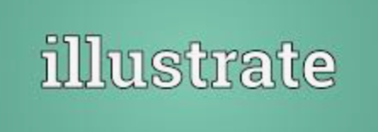 | Video  https://vimeo.com/466529487  True and False  https://resources.whiterosemaths.com/wp-content/uploads/2019/12/T-or-F-Year-5-S3-Use-line-graphs-to-solve-problems.pdf  Work sheet  https://resources.whiterosemaths.com/wp-content/uploads/2019/09/Y5-Autumn-Block-3-WO3-Use-line-graphs-to-solve-problems-2019.pdf  Answers  https://resources.whiterosemaths.com/wp-content/uploads/2020/10/Y5-Autumn-Block-3-ANS3-Use-line-graphs-to-solve-problems.pdf | PSHE  https://www.loom.com/share/edbb9f8cc382471cac629e50c799c7ab  Watch the online recorded lesson of Mrs Doe.  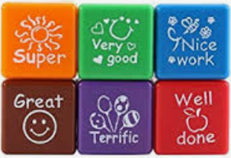  You have now made it to the last week of this term-well done all of you. As I can’t see you all now in person, I have set you a task to help you to get the praise you deserve. Have a go at the Self-praise jar activity.  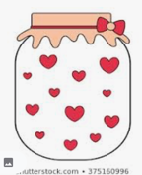  Then have a look through the Wellbeing Challenge Leaflet. You don’t have to do it all this week, it’s for you to use during half-term as well. Remember, no pressure, choose the parts you enjoy, it is not meant to be stressful!

English ideas:
https://www.literacyshed.com/story-starters.html
Online dictionary -https://kids.wordsmyth.net/we/
Pobble 365 Writing activities https://www.pobble365.com/
Maths ideas:
Pixl –practise tables using the App
Nrich -https://nrich.maths.org/primary
Worksheets to practise tables: http://www.snappymaths.com/

Keeping active:
Cosmic kids yoga –mainly on Youtube check with an adult
GoNoodle -https://app.gonoodle.com/
The Woodland trust - https://www.woodlandtrust.org.uk/support-us/act/your-school/resources/
Joe Wicks daily work out

CBBC: has lots of programmes from ‘Horrible Histories’ to ‘Operation Ouch’

