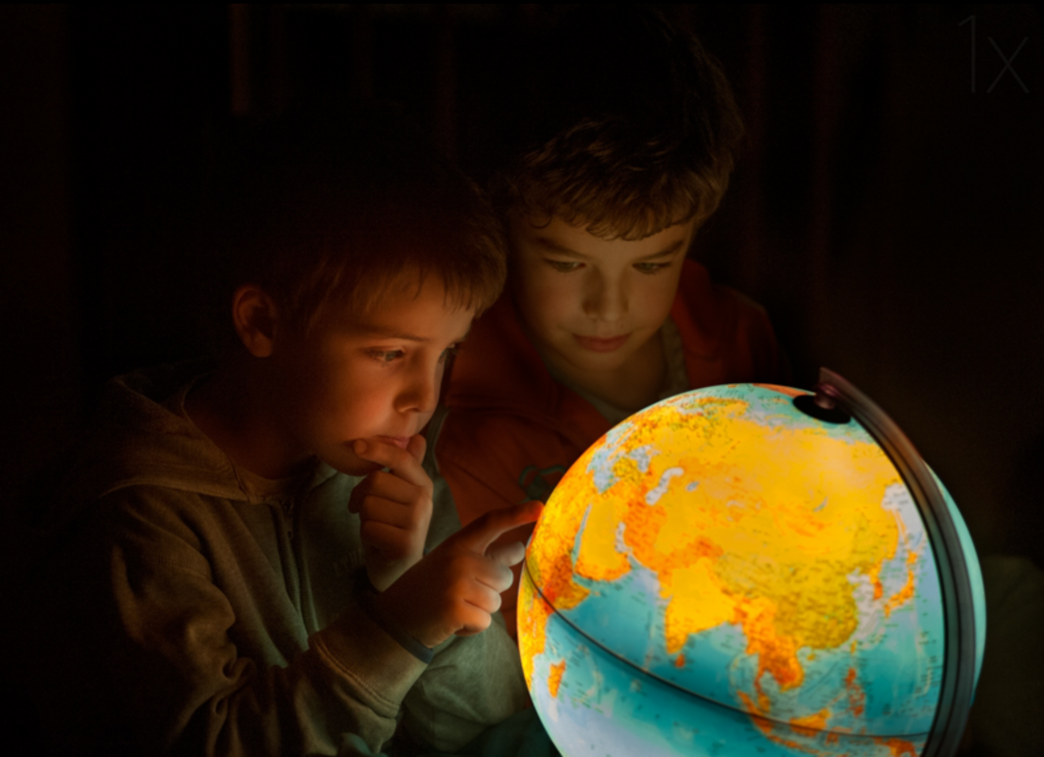
Story starter!
“Hmmm. Where shall we go this time?” Jeremy asked his brother.
“How about there!?” replied Max excitedly. “We’ve always talked about going there!”
The brothers both put their fingers on the part of the world they had chosen, and waited for the magic to happen.
“I wonder if it will be as fun as our last trip,” mused Jeremy, as the globe began to glow…

Sentence Challenge
Can you think of things the boys might be saying to each other?
Can you write down what they will say next?
Remember to use inverted commas/speech marks, and to start a new line for a new speaker.

