School Closure Daily Planning- Opal Class
DATE | Reading | Writing | Mathematics | Other
Wednesday.24.02.21 | Reread the text from Monday then complete the comprehension sheet below:  Y.1  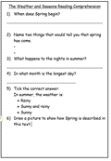  Y.2  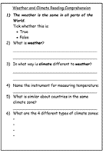 | Today, you will be writing an explanation about how to observe and record the weather. Try to think about what things you have seen and done already this week, about observing and recording the weather and include some of this information in your writing. | The Y.2 maths becomes quite complicated today. Please encourage your child to complete the Y.1 task, if you think this would be more appropriate for them. Please be reassured that I intend to revisit subtraction of two 2-digit numbers, on the return to school.  Y. 2  Please watch this video about subtracting two 2-digit numbers and then complete the worksheet below:  https://vimeo.com/468561808  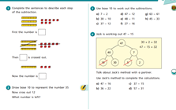  Y.1  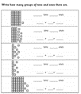 | Use the information provided to form a set of instructions about how to draw your crazy character.  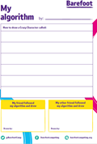

Useful websites for other home learning ideas and activities.

Here are a few suggestions of websites you may like to browse, for ideas of other home learning activities you could carry out with your children, during this lockdown period. I am sure there are many others available too. As I discover new ones to recommend, I will add to the list.
https://www.bbc.co.uk/bitesize/levels/z3g4d2p
Learning videos, games and activities for children from aged 3-16+
https://home.oxfordowl.co.uk/reading/free-ebooks/
Free ebook library – just sign up!
https://whiterosemaths.com/homelearning/
White Rose home learning resources. Ideal for reinforcing many of the concepts covered last term.
https://www.barefootcomputing.org/homelearning
Lots of activities you can carry out at home with your child, to help them develop skills linked to the ICT curriculum, which don’t actually require screen time. Also, a couple of very good interactive screen time activities provided.
https://www.stem.org.uk/home-learning/primary
Lots of amazing ideas for more science and technology activities.
http://www.robbiddulph.com/draw-with-rob
For those of you who like drawing, some short video lessons, by the illustrator, Rob Biddulph.
https://www.natgeokids.com/uk/teacher-category/primary-resources/
A variety of resources for most curriculum areas.

