School Closure Daily Planning- Opal Class
DATE | Reading | Writing | Mathematics | Other
Wednesday.10.02.21 | Reread the text from Monday then complete the comprehension sheet below:  Y.1  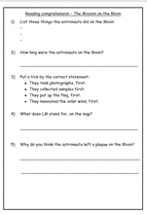  Y.2  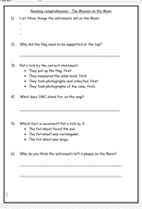 | Today, you will plan your story using the sheet below:  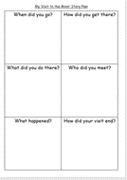 | Y. 1  Please watch the video below, about comparing numbers within 50, then complete the sheet. https://vimeo.com/503102857  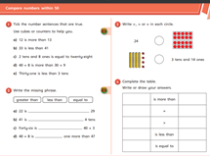  Y.2  Please watch the video below, about adding one and two-digit numbers, then complete the sheet.  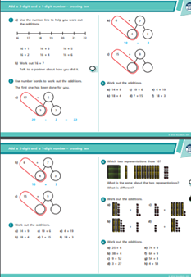 | Go for your Wednesday mile walk or jog. When you get home, watch this episode of The Clangers.  https://www.bbc.co.uk/iplayer/episode/b05zh5dp/clangers-series-1-1-the-lost-notes  Compare it to the one you watched on Monday.  - Which episode do you think is most recent? Why?  - What is the same about each episode and what is different?  - Which did you enjoy most? Why?

Useful websites for other home learning ideas and activities.

Here are a few suggestions of websites you may like to browse, for ideas of other home learning activities you could carry out with your children, during this lockdown period. I am sure there are many others available too. As I discover new ones to recommend, I will add to the list.
https://www.bbc.co.uk/bitesize/levels/z3g4d2p
Learning videos, games and activities for children from aged 3-16+
https://home.oxfordowl.co.uk/reading/free-ebooks/
Free ebook library – just sign up!
https://whiterosemaths.com/homelearning/
White Rose home learning resources. Ideal for reinforcing many of the concepts covered last term.
https://www.barefootcomputing.org/homelearning
Lots of activities you can carry out at home with your child, to help them develop skills linked to the ICT curriculum, which don’t actually require screen time. Also, a couple of very good interactive screen time activities provided.
https://www.stem.org.uk/home-learning/primary
Lots of amazing ideas for more science and technology activities.
http://www.robbiddulph.com/draw-with-rob
For those of you who like drawing, some short video lessons, by the illustrator, Rob Biddulph.
https://www.natgeokids.com/uk/teacher-category/primary-resources/
A variety of resources for most curriculum areas.

