School Closure Daily Planning- Opal Class
DATE | Reading | Writing | Mathematics | Other
Wednesday.03.02.21 | Reread the newspaper report from Monday then complete the comprehension sheet below:  Y.1  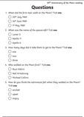  Y.2  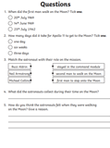 | Yesterday, you wrote the introductory sentences for your newspaper report about The Paper Bag Princess. Today, in your writing, I would like you to help write the next part of the newspaper report, by thinking about the best verbs to use in the spaces in the paragraph on the sheet below:  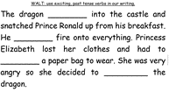 | Y. 1  Please watch the lesson in the link below and then complete the sheet:  https://vimeo.com/500467998  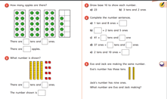  Y.2  Today, you will be recapping your learning on block diagrams. (Think back to when we made block diagrams on the computer about materials, last term).  Complete the worksheets below.  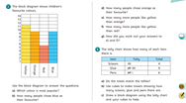  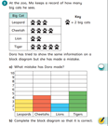 | Go on your Wednesday mile walk or jog. While you are out look at the vehicles around you. Think about the way they look.  - What shapes can you see on them?  - What are the windows like?  - What are the doors like?  - What other features can you see and what do you think is their purpose?

Useful websites for other home learning ideas and activities.

Here are a few suggestions of websites you may like to browse, for ideas of other home learning activities you could carry out with your children, during this lockdown period. I am sure there are many others available too. As I discover new ones to recommend, I will add to the list.
https://www.bbc.co.uk/bitesize/levels/z3g4d2p
Learning videos, games and activities for children from aged 3-16+
https://home.oxfordowl.co.uk/reading/free-ebooks/
Free ebook library – just sign up!
https://whiterosemaths.com/homelearning/
White Rose home learning resources. Ideal for reinforcing many of the concepts covered last term.
https://www.barefootcomputing.org/homelearning
Lots of activities you can carry out at home with your child, to help them develop skills linked to the ICT curriculum, which don’t actually require screen time. Also, a couple of very good interactive screen time activities provided.
https://www.stem.org.uk/home-learning/primary
Lots of amazing ideas for more science and technology activities.
http://www.robbiddulph.com/draw-with-rob
For those of you who like drawing, some short video lessons, by the illustrator, Rob Biddulph.
https://www.natgeokids.com/uk/teacher-category/primary-resources/
A variety of resources for most curriculum areas.

