School Closure Daily Planning- Opal Class
DATE | Reading | Writing | Mathematics | Other
Tuesday  09.02.21 | Refer back to the list of words you made yesterday. Today, I would like you to look up their meaning, using a dictionary. Choose two of these words and write a sentence for each one, to show that you understand what each means and can now use them yourself. | This week, we are going to write a story about a visit to the Moon. Today, we are going to listen to a story about a regular visitor to the Moon, to inspire our own stories. Either listen to me read the story, or watch it being read here:  https://www.youtube.com/watch?v=Rt5zQ1UO6rE | Y. 1  Please watch the video below, about comparing numbers up to 50 and then complete the worksheet.  https://vimeo.com/503099894  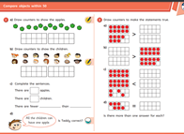  Y.2  Please watch the video below, about making 10’s when adding two numbers together (this is a recap, as it is quite a challenging concept). Then complete the sheet below:  https://vimeo.com/464197249  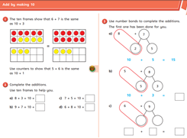 | Complete the Joe Wicks workout.  Today, I would like you research the dates in which the events on the sheet below, from the last century, happened. Each one comes from a different decade. Then I would like you to cut them out and place them in order, on a timeline. You will need to think about the meaning of the highlighted words first and look them up, if you don’t know their meaning.  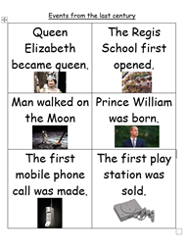

Useful websites for other home learning ideas and activities.

Here are a few suggestions of websites you may like to browse, for ideas of other home learning activities you could carry out with your children, during this lockdown period. I am sure there are many others available too. As I discover new ones to recommend, I will add to the list.
https://www.bbc.co.uk/bitesize/levels/z3g4d2p
Learning videos, games and activities for children from aged 3-16+
https://home.oxfordowl.co.uk/reading/free-ebooks/
Free ebook library – just sign up!
https://whiterosemaths.com/homelearning/
White Rose home learning resources. Ideal for reinforcing many of the concepts covered last term.
https://www.barefootcomputing.org/homelearning
Lots of activities you can carry out at home with your child, to help them develop skills linked to the ICT curriculum, which don’t actually require screen time. Also, a couple of very good interactive screen time activities provided.
https://www.stem.org.uk/home-learning/primary
Lots of amazing ideas for more science and technology activities.
http://www.robbiddulph.com/draw-with-rob
For those of you who like drawing, some short video lessons, by the illustrator, Rob Biddulph.
https://www.natgeokids.com/uk/teacher-category/primary-resources/
A variety of resources for most curriculum areas.

