School Closure Daily Planning- Opal Class
DATE | Reading | Writing | Mathematics | Other
Tuesday  02.02.21 | Yesterday you read the newspaper report about the first man on the moon and listened to the story of The Paper Bag Princess. Think about what is the same and what is different about these two texts. (Think about the features we discussed in our writing lesson yesterday, when we were looking at the newspaper report. Are these the same in the story?) | Yesterday, we agreed what features a newspaper report has, and you wrote the headline for your report of what happened to the Paper Bag Princess. Today, you are going to write the introductory sentences for your report. They need to sum up the story. Look at the reading text from yesterday. Can you model your first sentences on the ones in this report? They will need to include these facts from the story of The Paper Bag Princess:  - When it happened.  - What happened (the Prince was kidnapped).  - Where it happened.  - Who did it.  - Who saved the Prince. | Y. 1  Please watch the lesson in the link below and then complete the sheets:  https://vimeo.com/500467345  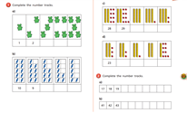  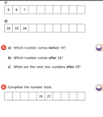  Y.2  Please watch the lesson in the link below and then complete the sheets:  https://vimeo.com/504483835  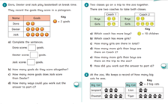  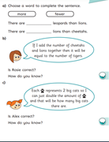 | Complete the Joe Wicks workout.  Watch the video below, which shows the capsule that the Apollo 11 astronauts flew back to Earth in, after landing on the moon.  https://www.youtube.com/watch?v=llYsvfhCKco  - What is it made from?  - How would you describe its shape?  - What other shapes can you see?  - How much space is there inside?  - Where is the door?  - How many windows does it have?  Choose three of the labels you do not understand and research what they mean.

Useful websites for other home learning ideas and activities.

Here are a few suggestions of websites you may like to browse, for ideas of other home learning activities you could carry out with your children, during this lockdown period. I am sure there are many others available too. As I discover new ones to recommend, I will add to the list.
https://www.bbc.co.uk/bitesize/levels/z3g4d2p
Learning videos, games and activities for children from aged 3-16+
https://home.oxfordowl.co.uk/reading/free-ebooks/
Free ebook library – just sign up!
https://whiterosemaths.com/homelearning/
White Rose home learning resources. Ideal for reinforcing many of the concepts covered last term.
https://www.barefootcomputing.org/homelearning
Lots of activities you can carry out at home with your child, to help them develop skills linked to the ICT curriculum, which don’t actually require screen time. Also, a couple of very good interactive screen time activities provided.
https://www.stem.org.uk/home-learning/primary
Lots of amazing ideas for more science and technology activities.
http://www.robbiddulph.com/draw-with-rob
For those of you who like drawing, some short video lessons, by the illustrator, Rob Biddulph.
https://www.natgeokids.com/uk/teacher-category/primary-resources/
A variety of resources for most curriculum areas.

