School Closure Daily Planning- Opal Class
DATE | Reading | Writing | Mathematics | Other
Thursday 11.02.21 | How many words can you read correctly, on the sheet below? Can you find the compound word? Can you spot the two hidden aliens and draw an alien next to each?  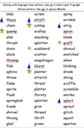 | Today we are going to write the first part of our story. | Y. 1  Please watch the video about ordering numbers within 50, and then complete the sheet below:  https://vimeo.com/503093819  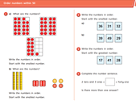  Y.2  Please watch the video about crossing 10 when subtracting, and then complete the sheet below:  https://vimeo.com/465728628  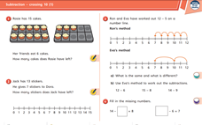 | The Clangers like to make useful things out of space junk. What could you make out of the junk in your recycling bin today? Be imaginative but try to make something you will be able to use. Please send me a photograph of your invention.

Useful websites for other home learning ideas and activities.

Here are a few suggestions of websites you may like to browse, for ideas of other home learning activities you could carry out with your children, during this lockdown period. I am sure there are many others available too. As I discover new ones to recommend, I will add to the list.
https://www.bbc.co.uk/bitesize/levels/z3g4d2p
Learning videos, games and activities for children from aged 3-16+
https://home.oxfordowl.co.uk/reading/free-ebooks/
Free ebook library – just sign up!
https://whiterosemaths.com/homelearning/
White Rose home learning resources. Ideal for reinforcing many of the concepts covered last term.
https://www.barefootcomputing.org/homelearning
Lots of activities you can carry out at home with your child, to help them develop skills linked to the ICT curriculum, which don’t actually require screen time. Also, a couple of very good interactive screen time activities provided.
https://www.stem.org.uk/home-learning/primary
Lots of amazing ideas for more science and technology activities.
http://www.robbiddulph.com/draw-with-rob
For those of you who like drawing, some short video lessons, by the illustrator, Rob Biddulph.
https://www.natgeokids.com/uk/teacher-category/primary-resources/
A variety of resources for most curriculum areas.

