School Closure Daily Planning- Opal Class
DATE | Reading | Writing | Mathematics | Other
Monday  08.02.21  10.30:  Class Zoom meeting | Please watch the video and use the appropriate text as suggested.  Y.1  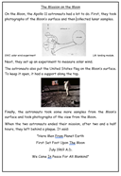  Y.2  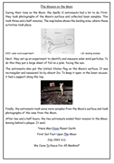  Highlight any words you do not understand. Make a list of these. Discuss them with a grown up. Can you guess what they mean? | Y.1  Highlight all the verbs in the reading text. What tense are these in? Then, complete the sorting activity about verb tenses using the cut and stick sheets. Think about the endings of the past tense verbs. Do they always end with an ‘ed’?  Y.2  Highlight the words with the suffixes ‘ed’ and ‘ing’ in the reading text. Then complete the sheet about the suffixes below:  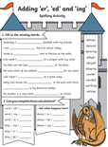 | Y.1  Please watch the video below about 1 more and 1 less.  https://vimeo.com/503098045  Then complete the worksheet.  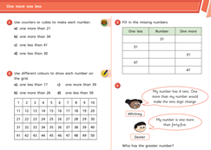  Y.2  Please watch the video below about adding and subtracting 10 and then complete the sheet.  https://vimeo.com/464237963  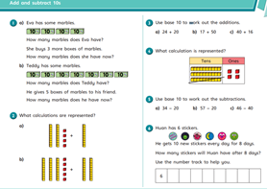 | Today, I would like you to compare the two videos below:  https://www.youtube.com/watch?v=cwZb2mqId0A  https://www.youtube.com/watch?v=Ok6CoIwcJ-E  - They were both filmed in the same year. What year was this?  - What makes them different?  - In what ways are they the same? Think about the scenery.  - What do you think gave the creators of the second video the idea for this programme?

Useful websites for other home learning ideas and activities.
Here are a few suggestions of websites you may like to browse, for ideas of other home learning activities you could carry out with your children, during this lockdown period. I am sure there are many others available too. As I discover new ones to recommend, I will add to the list.
https://www.bbc.co.uk/bitesize/levels/z3g4d2p
Learning videos, games and activities for children from aged 3-16+
https://home.oxfordowl.co.uk/reading/free-ebooks/
Free ebook library – just sign up!
https://whiterosemaths.com/homelearning/
White Rose home learning resources. Ideal for reinforcing many of the concepts covered last term.
https://www.barefootcomputing.org/homelearning
Lots of activities you can carry out at home with your child, to help them develop skills linked to the ICT curriculum, which don’t actually require screen time. Also, a couple of very good interactive screen time activities provided.
https://www.stem.org.uk/home-learning/primary
Lots of amazing ideas for more science and technology activities.
http://www.robbiddulph.com/draw-with-rob
For those of you who like drawing, some short video lessons, by the illustrator, Rob Biddulph.
https://www.natgeokids.com/uk/teacher-category/primary-resources/
A variety of resources for most curriculum areas.

