School Closure Daily Planning- Opal Class
DATE | Reading | Writing | Mathematics | Other
Friday 12.02.21 | Please watch this video when you have finished writing your story. You will need the sheet below for the video lesson:  (Who can spot the mistake in the last line that even my ‘editor’s eye’ missed?!)  Now read back through your own story with your ‘editor’s eyes’. You need to check:  - You haven’t missed any words.  - You have spelt the common exception words correctly.  - You have used the correct sentence punctuation. | Today you are going to use your plan, as you did yesterday, to write the last part of your story. | Please follow the link for a maths investigation involving the addition of the digits in 2-digit numbers:  https://nrich.maths.org/14312/note  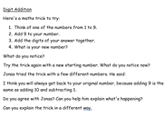 | Cosmic Yoga with Jaime. Take a magic carpet ride, so that you can complete the final activity with a clear head!  https://www.youtube.com/watch?v=yRGJEyqi55o&list=PL8snGkhBF7nhTxJt1M7d6A7mmD3kK6wE1&index=47  Quiz  Answer the questions on the sheet below, about our topic from this term.  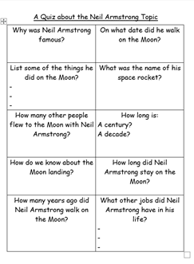

Useful websites for other home learning ideas and activities.

Here are a few suggestions of websites you may like to browse, for ideas of other home learning activities you could carry out with your children, during this lockdown period. I am sure there are many others available too. As I discover new ones to recommend, I will add to the list.
https://www.bbc.co.uk/bitesize/levels/z3g4d2p
Learning videos, games and activities for children from aged 3-16+
https://home.oxfordowl.co.uk/reading/free-ebooks/
Free ebook library – just sign up!
https://whiterosemaths.com/homelearning/
White Rose home learning resources. Ideal for reinforcing many of the concepts covered last term.
https://www.barefootcomputing.org/homelearning
Lots of activities you can carry out at home with your child, to help them develop skills linked to the ICT curriculum, which don’t actually require screen time. Also, a couple of very good interactive screen time activities provided.
https://www.stem.org.uk/home-learning/primary
Lots of amazing ideas for more science and technology activities.
http://www.robbiddulph.com/draw-with-rob
For those of you who like drawing, some short video lessons, by the illustrator, Rob Biddulph.
https://www.natgeokids.com/uk/teacher-category/primary-resources/
A variety of resources for most curriculum areas.

