School Closure Daily Planning- Opal Class
DATE | Reading | Writing | Mathematics | Other
Friday 05.02.21 | Read the words on the sheet below, then cut them out and place them in alphabetical order:  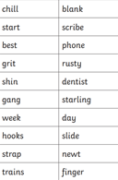 | Today, in your writing, I would like you to finish your newspaper report by reporting on how Prince Ronald reacted when Elizabeth rescued him.  After you have done this, please draw a picture to illustrate your newspaper report. | Place value investigation:  Please read the sheet below and investigate the solutions:  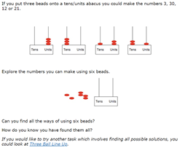  If you follow the link below, there are suggestions of how to help your child solve this problem and possible extensions.  https://nrich.maths.org/152/note | Today’s Cosmic Yoga session includes another dragon. I hope he is more friendly than the one in The Paper Bag Princess!  https://www.youtube.com/watch?v=7NWzS2xziI4  Click on the link below, to watch a video about the return of Neil Armstrong and his crew in their capsule.  https://www.youtube.com/watch?v=snCNhgY6r5o  Are there any improvements you could now like to make to your design of your return capsule, in light of what you have seen?

Useful websites for other home learning ideas and activities.

Here are a few suggestions of websites you may like to browse, for ideas of other home learning activities you could carry out with your children, during this lockdown period. I am sure there are many others available too. As I discover new ones to recommend, I will add to the list.
https://www.bbc.co.uk/bitesize/levels/z3g4d2p
Learning videos, games and activities for children from aged 3-16+
https://home.oxfordowl.co.uk/reading/free-ebooks/
Free ebook library – just sign up!
https://whiterosemaths.com/homelearning/
White Rose home learning resources. Ideal for reinforcing many of the concepts covered last term.
https://www.barefootcomputing.org/homelearning
Lots of activities you can carry out at home with your child, to help them develop skills linked to the ICT curriculum, which don’t actually require screen time. Also, a couple of very good interactive screen time activities provided.
https://www.stem.org.uk/home-learning/primary
Lots of amazing ideas for more science and technology activities.
http://www.robbiddulph.com/draw-with-rob
For those of you who like drawing, some short video lessons, by the illustrator, Rob Biddulph.
https://www.natgeokids.com/uk/teacher-category/primary-resources/
A variety of resources for most curriculum areas.

